**INDEX**

**05-08-2024**

1. Languages & Packages
2. Java Features
   1. Why Java is platform independent
3. JDK, JRE, JVM
4. Basic Java
   1. Datatypes
   2. Operators
   3. Conditions(if, if-else)
   4. Loops(Nested for loops)
5. Packages

CoreJAVA-Workspace :

CoreJAVA-Development

CoreJAVA-Application

**06-08-2024**

1. **Logical Programming**

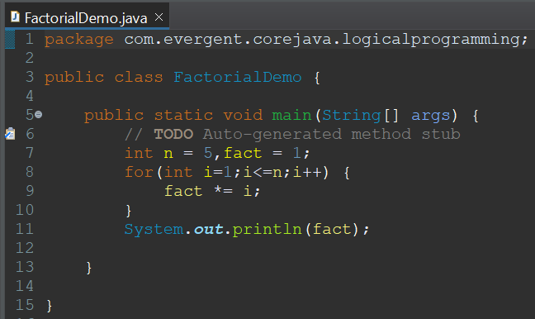

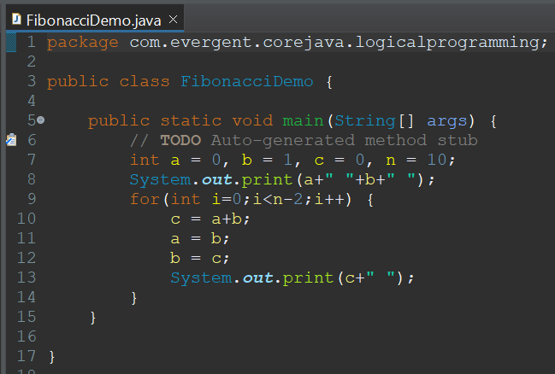

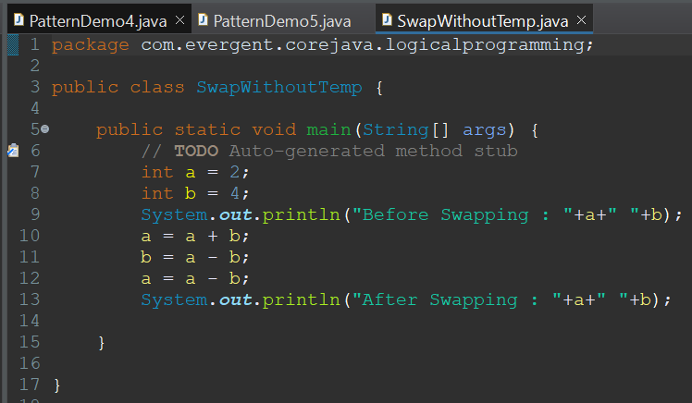

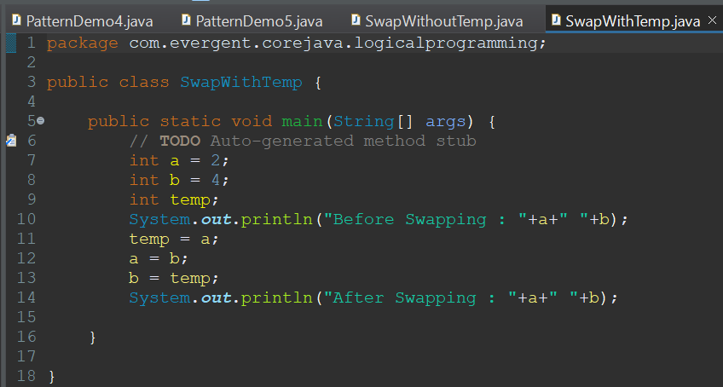

1. **Patterns**

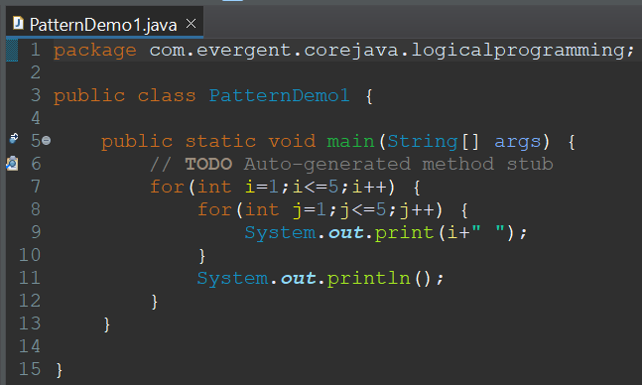

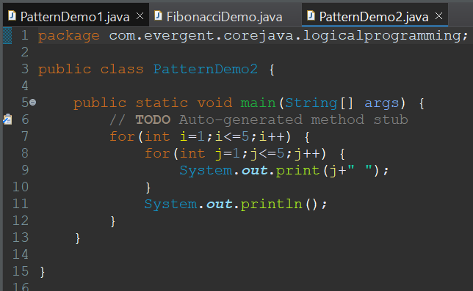

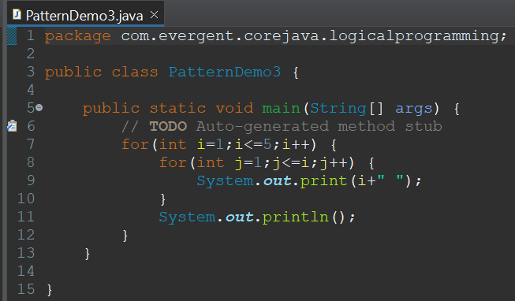

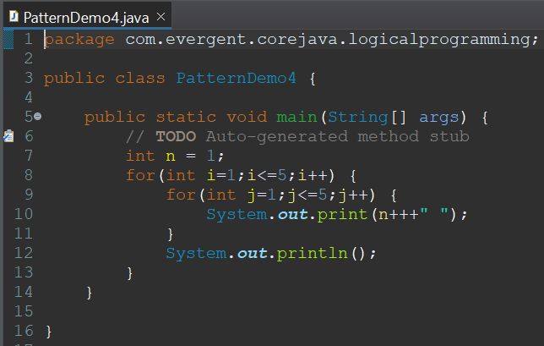

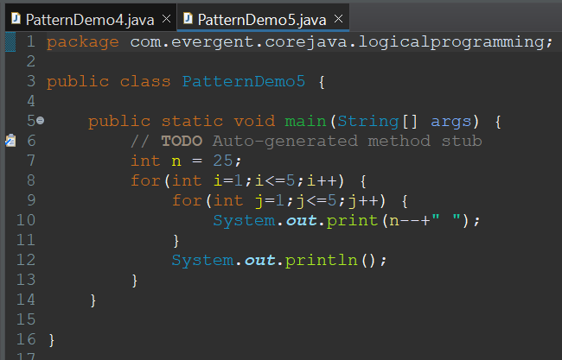

1. Switch Case

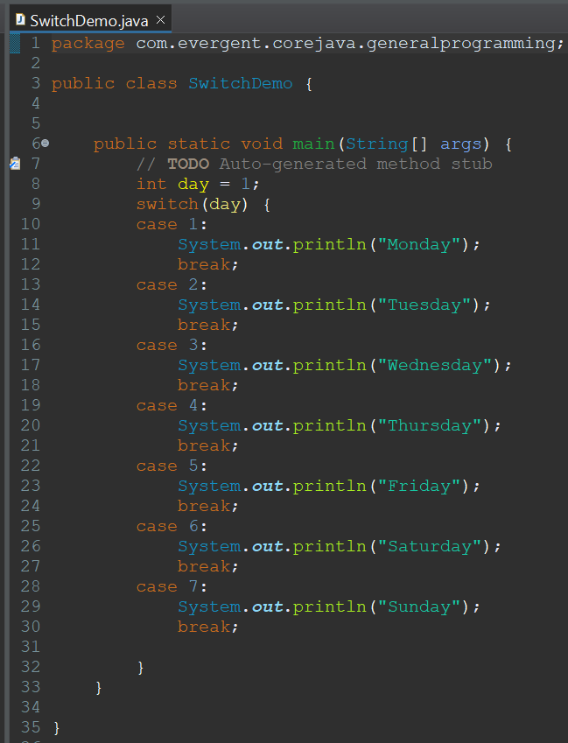

1. **Arrays**Arrays are used to store similar type of data in contiguous memory locations.  
   Arrays are of fixed size.  
   Arrays provide easy way to retrieve elements.  
   Arrays are of 2 types  
   a) 1D Arrays  
   b)2D Arrays
   1. 1D Array's

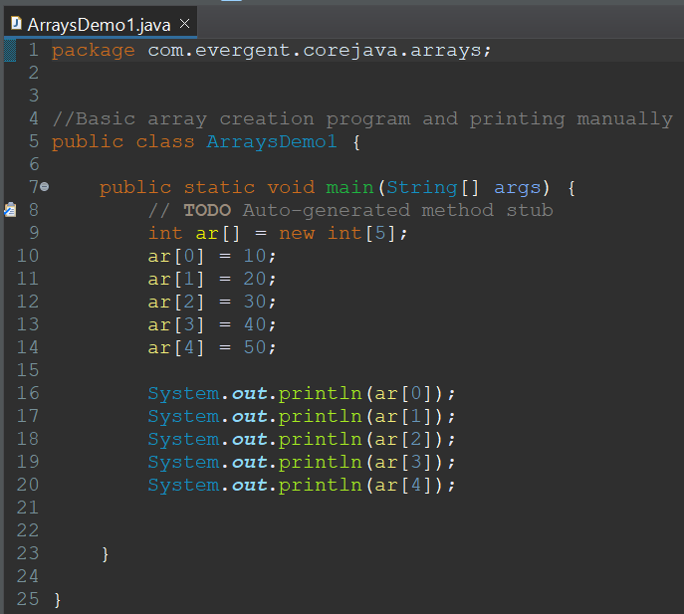

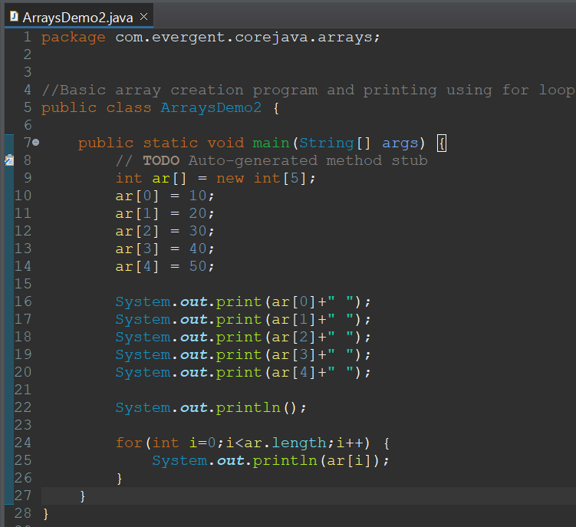

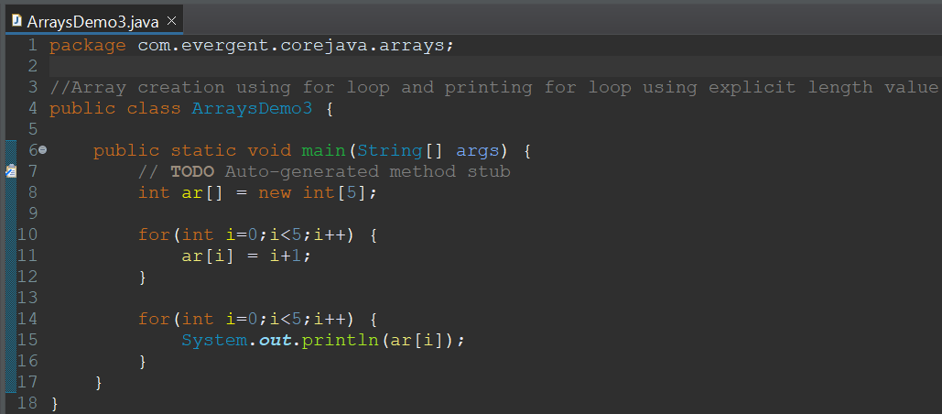

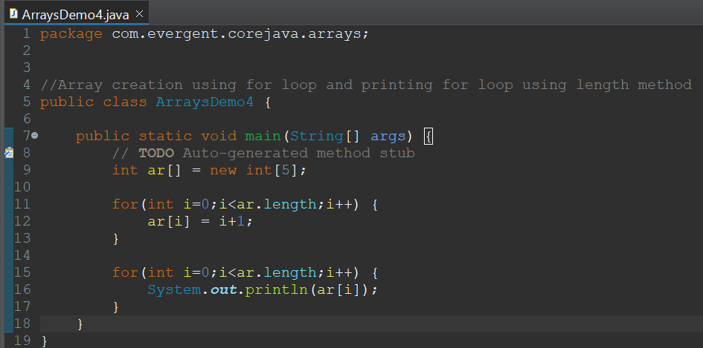

* 1. 2D Array's

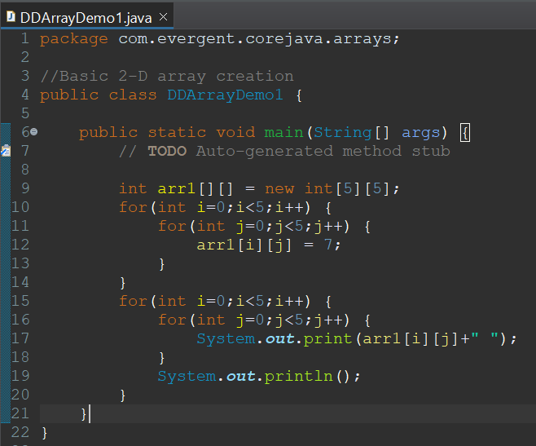

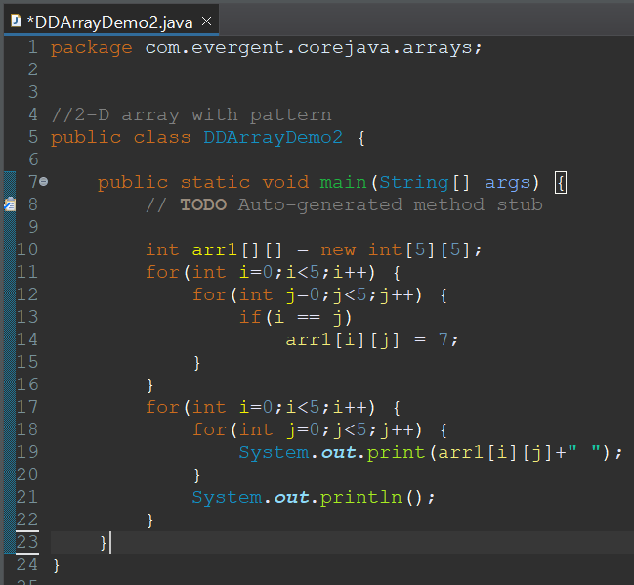

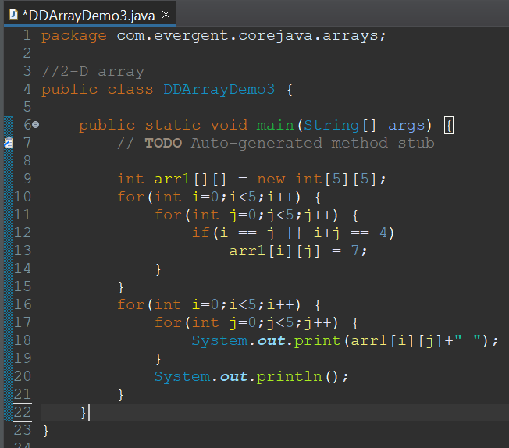

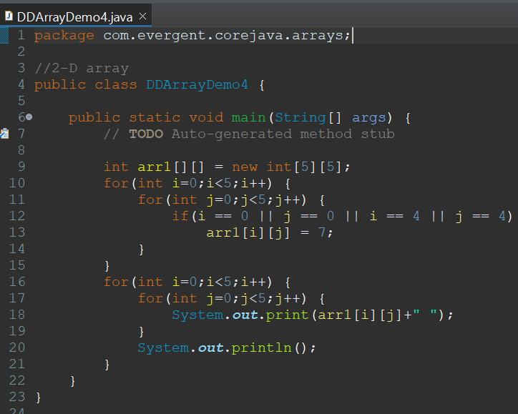

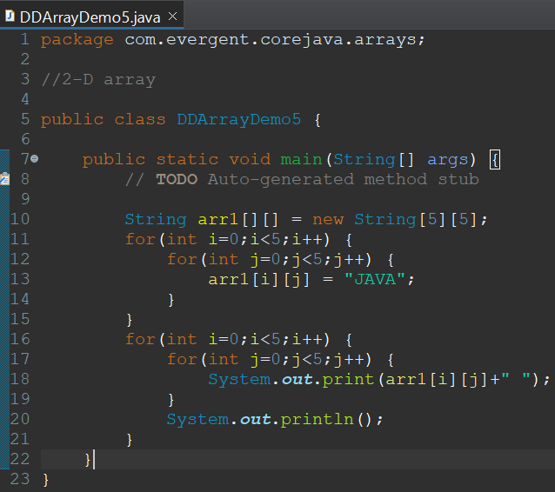

1. **Enum's  
   These are special classes which has their own data types.  
   These are constant’s that cannot be changed and should be in capital letter.  
   These are static and final by default.  
   During compile time only we know all values like deck of cards, colors, days etc.  
   We can add variables, methods and constructors in enums.  
   We cannot inherit other classes nor make enum class as super class to be extended.**
2. **Event Management System**

**07-08-2024**

1. **OOPS**
   1. Encapsulation  
      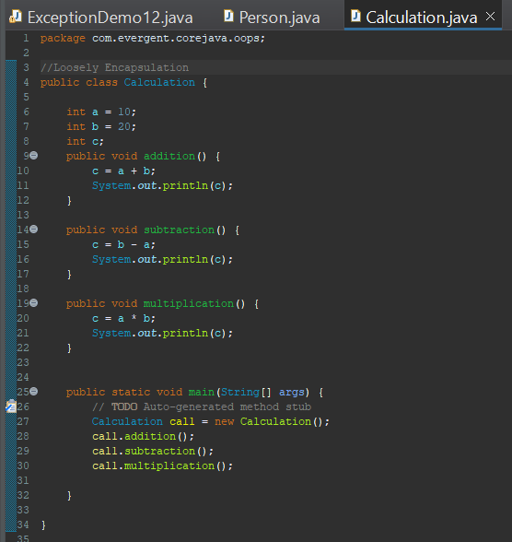
   2. Inheritance  
      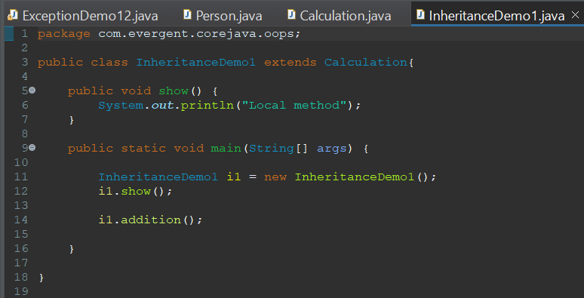  
      
   3. Polymorphism  
      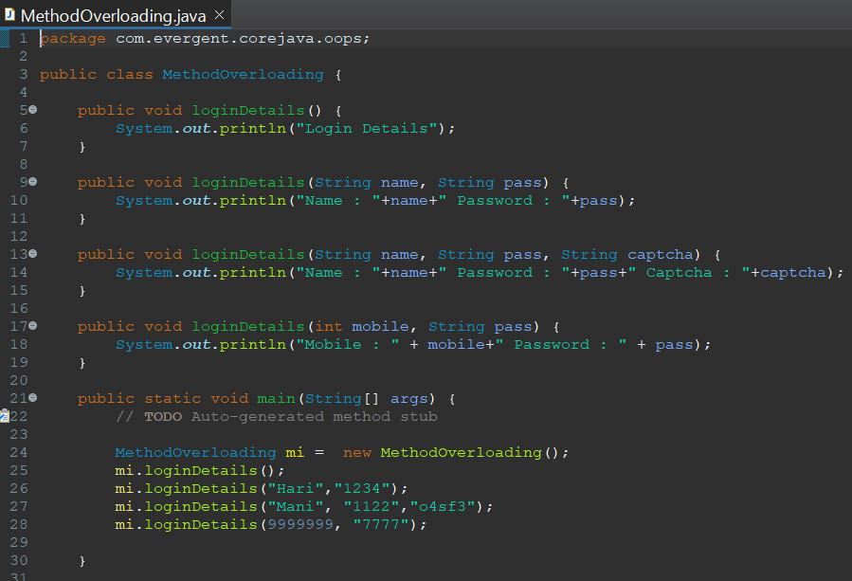  
      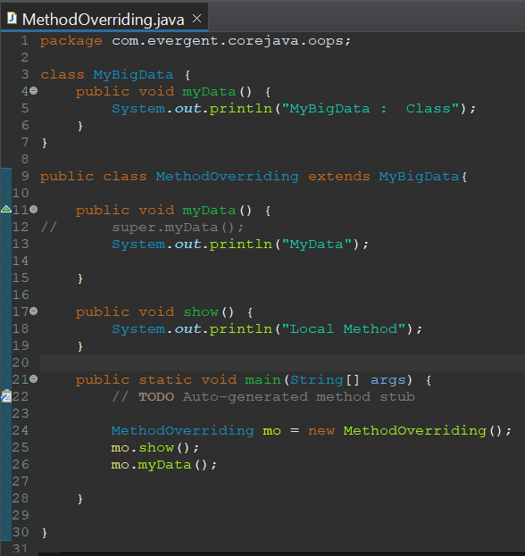
   4. Abstraction
   5. Method Flows  
       Method with return type and with out arguments.  
       Method with return type and with arguments.  
       Method with out return type and with out arguments.  
       Method with out return type and with arguments.
   6. IS-A and HAS-A relationship  
      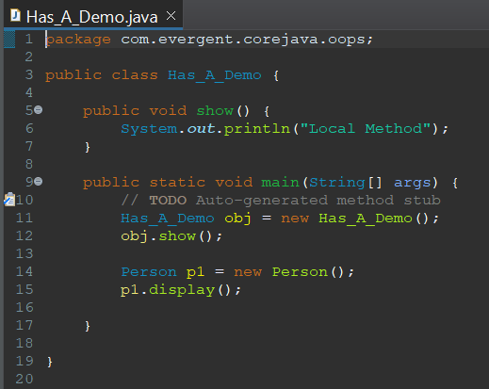
2. System class

**08-08-2024**

1. **Constructors**
   1. Constructor name should be equal to class name

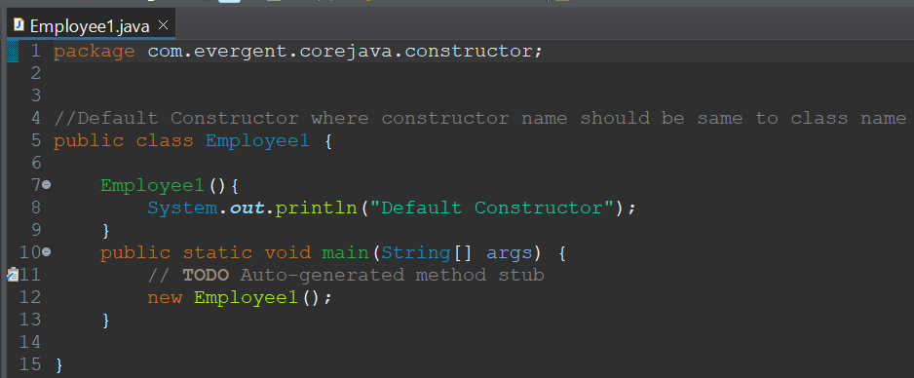

* 1. There are 2 types of constructor
     1. Default
     2. Parameterized

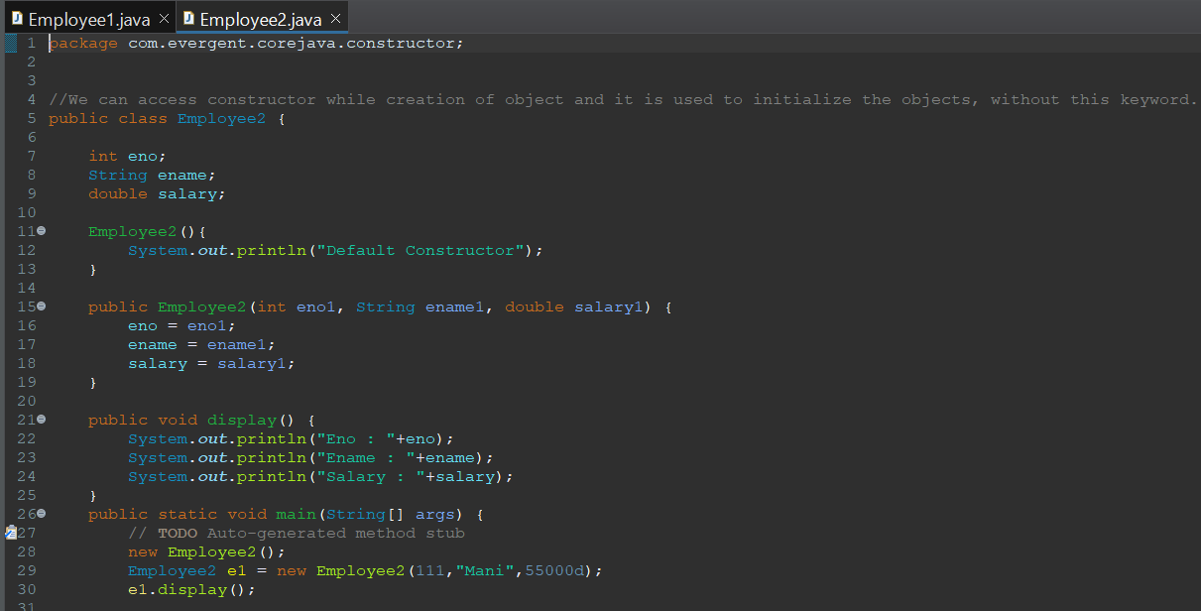

* 1. Constructors are called during object creation
  2. Constructors are used for initialization of objects
  3. Constructors doesn’t have return type not even void, if we define return type for constructors it will act as method

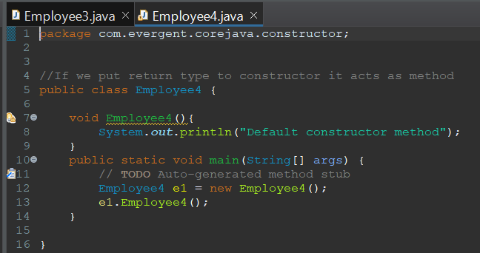

* 1. Every class will have default constructor
  2. this & super are used
  3. Also have other type of constructor called Copy Constructor

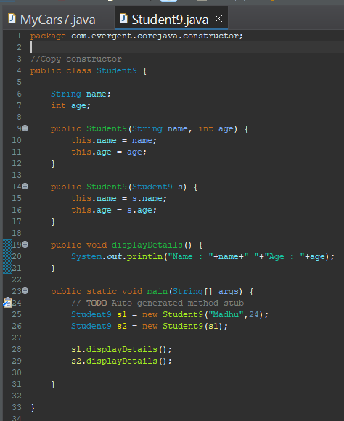

* 1. Constructors can be overloaded, but cannot be overridden
  2. Constructor chaining - this() is used to call current class constructor, super() is used to call super class constructor

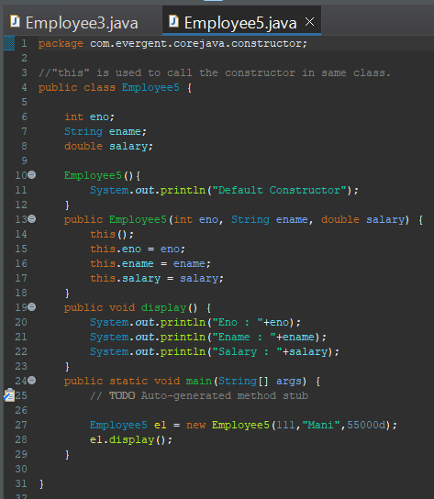

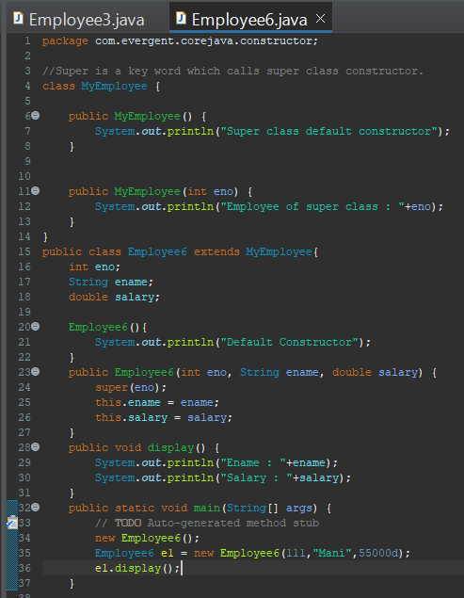

**09-08-2024**

1. **Static** 
   1. Static is a keyword
   2. We can declare variables and methods as static

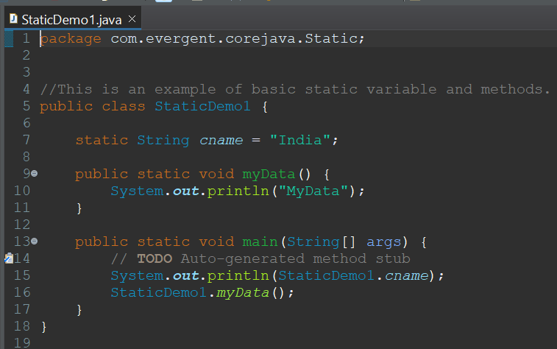

* 1. Static variables and methods are called by using ClassName.method and Classname.Variables
  2. Static method can access Static variables and Static methods

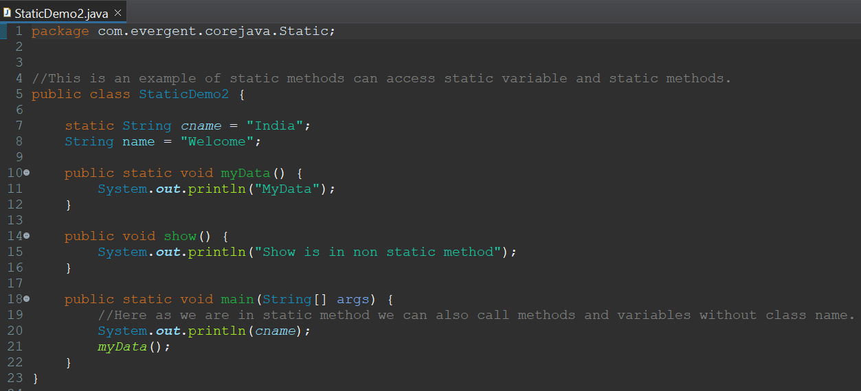

* 1. Static method cannot access Non static variables and Non static Methods

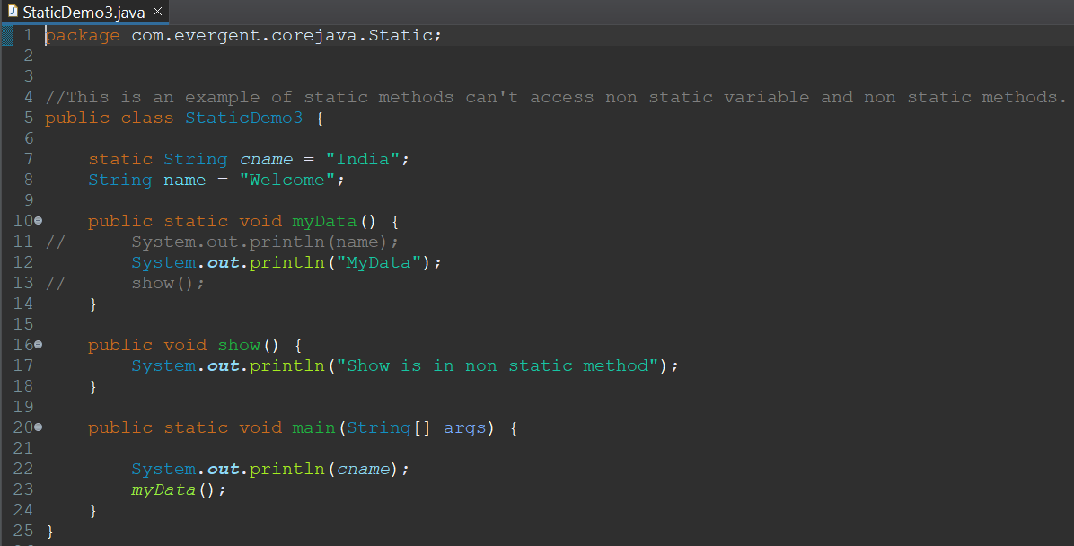

* 1. Non static method can access Static variables and Static methods

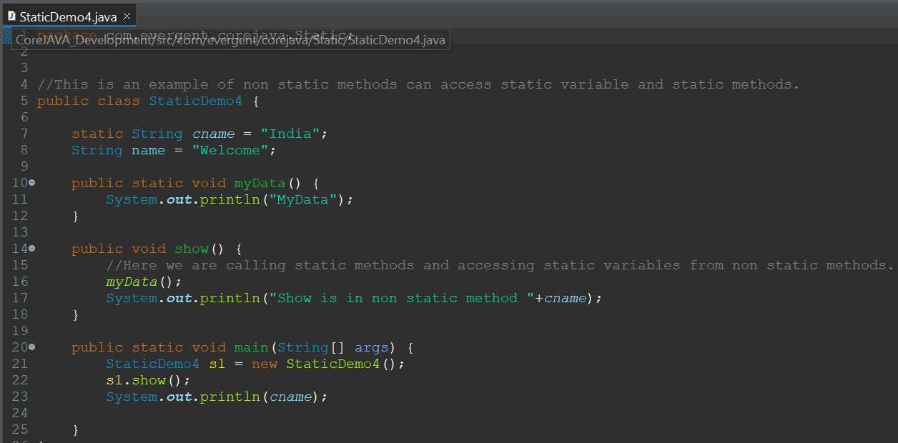

* 1. Static block is initialized first during class loading

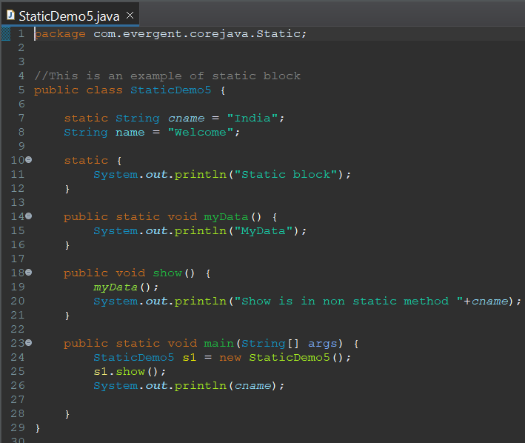

1. **Final**
   1. Final is a keyword
   2. We can declare Variables, Methods, Classes as final
   3. Final variables cannot be changed

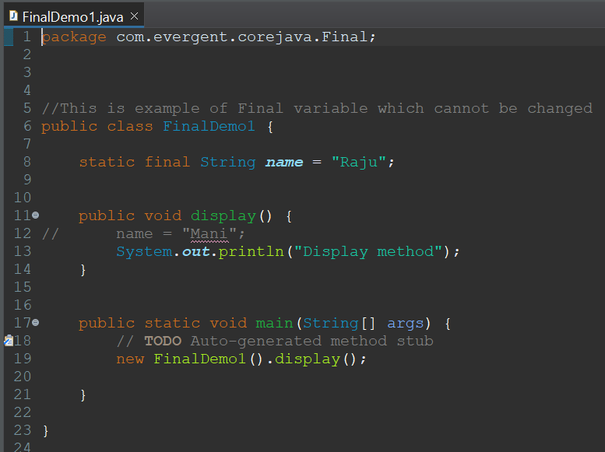

* 1. Final methods cannot be overridden

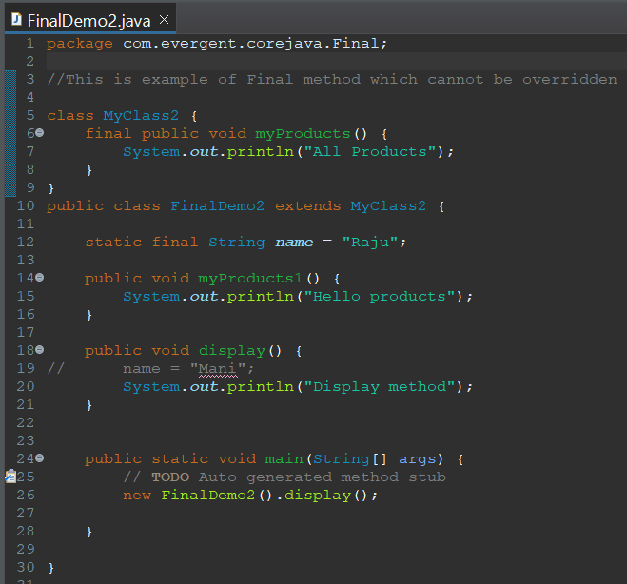

* 1. Final classes cannot be extended

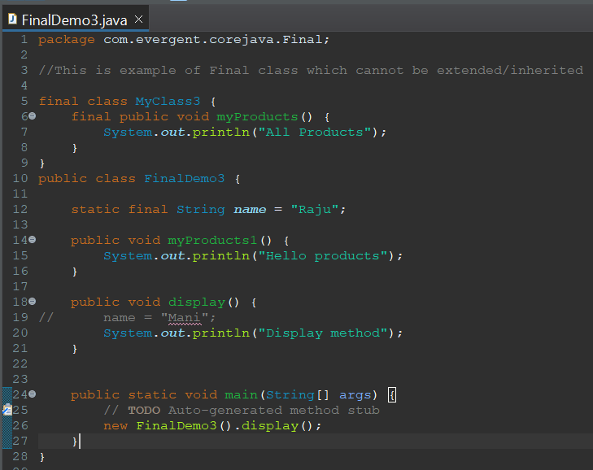

* 1. Final variables can be initialized through constructor or object creation
  2. Final variable can be accessed through HAS-A relation ship

**12-08-2024**

1. **String**
2. String Class
3. String Buffer
4. String Builder
5. String Class
6. String class is final
7. String is immutable
8. All string class methods are non synchronized
9. String Buffer
10. String Buffer class is final
11. String Buffer is mutable
12. All string buffer class methods are synchronized
13. String Builder
14. String Builder class is final
15. String Builder is mutable
16. All string builder class methods are non synchronized

|  |  |  |  |
| --- | --- | --- | --- |
| **S.No** | **String** | **String Buffer** | **String Builder** |
| 1. | Final class | Final class | Final class |
| 2. | Immutable | Mutable | Mutable |
| 3. | Non Synchronized(Not Thread safe) | Synchronized(Thread safe) | Non Synchronized(Not Thread safe) |
| 4. | String constant pool area | Heap area | Heap area |

String str1 = new String(“JAVA”)  
String str2 = new String(“JAVA”)

**HEAP AREA**

**“JAVA”**

STR1

**“JAVA”**

**String Object**

**“JAVA”**

STR2

**STRING POOL AREA**

S1

S2

**String Literal**

String str1 = “JAVA”  
String str2 = “JAVA”

**String class points**

1. In java a string is a sequence of characters, often used to represent text.
2. String are objects in java & instance of string class which is part of java.lang.package.
3. Key features of string in java
   1. Immutable : Once a string object is created it cannot be changed.
   2. Any modification to string creates a new string object
4. Java optimizes memory usage by storing strings in a special way area of memory called “String Constant Pool”.
5. If two strings have same value and are created without using new keyword they will refer to same object in string pool.
6. String methods are :   
   length()  
   trim()  
   toLowerCase()  
   toUpperCase()  
   append()  
   indexOf()  
   strip()  
   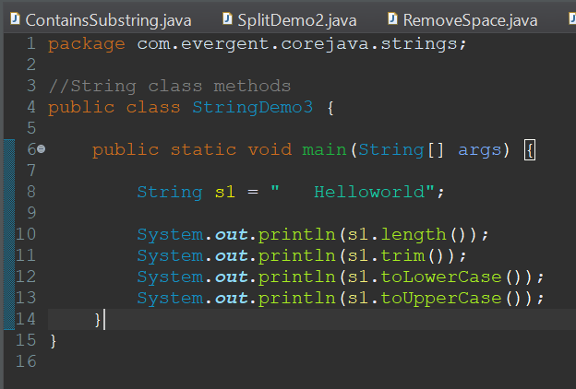  
   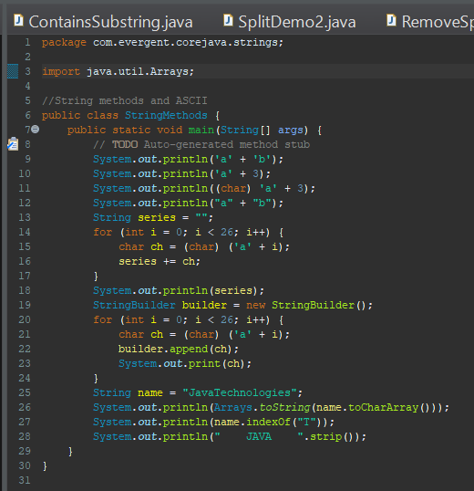
7. String contains() method is used to check whether substring is present or not.  
   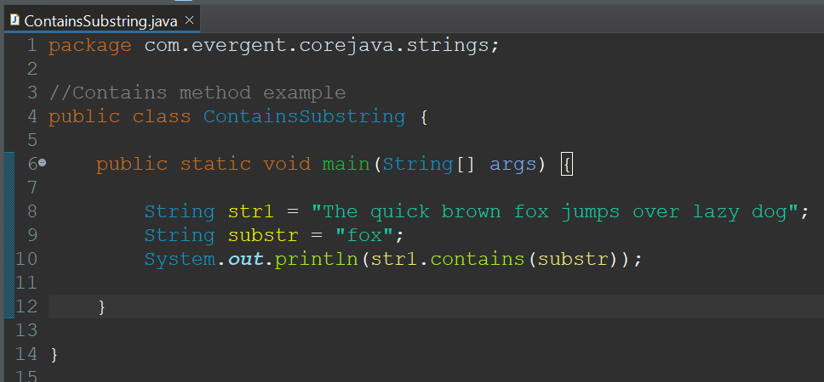
8. String replace() method is used to replace other values  
   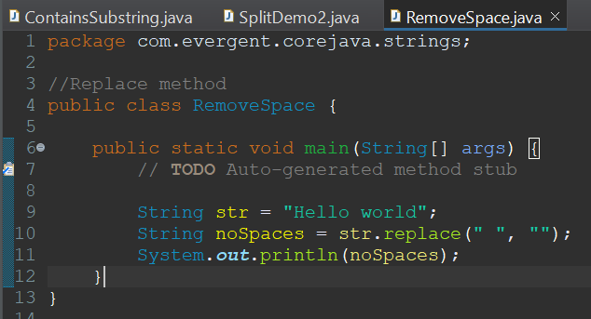
9. String reverse() method is used to reverse the string
10. String concat() method is used to reverse the string  
    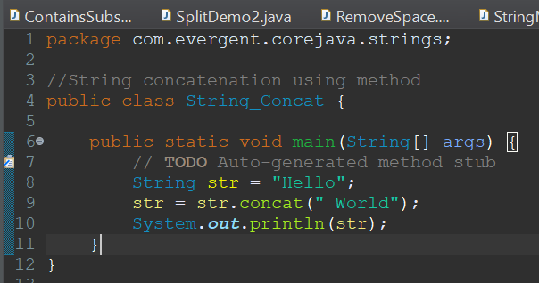
11. Split method is used to split the sentence into words.  
    I)Using for loop  
    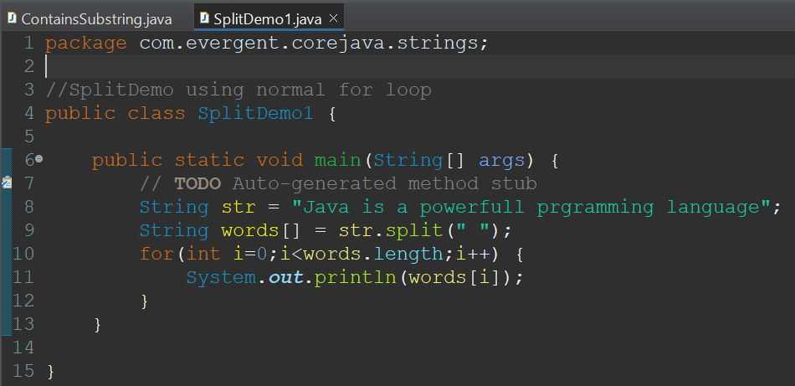  
    II)Using for each loop  
    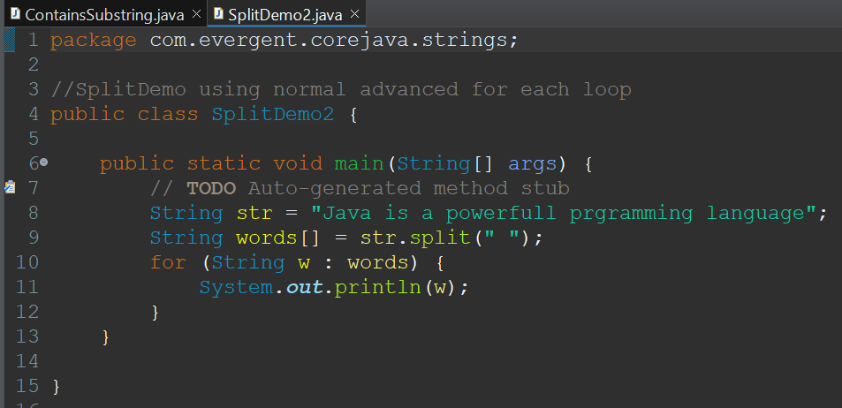
12. We can create string using in two ways :
    1. Using String literals

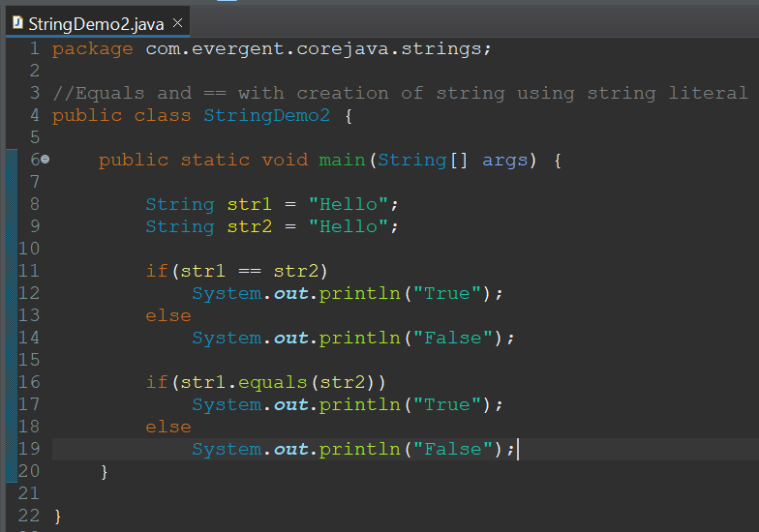

* 1. Using new keyword

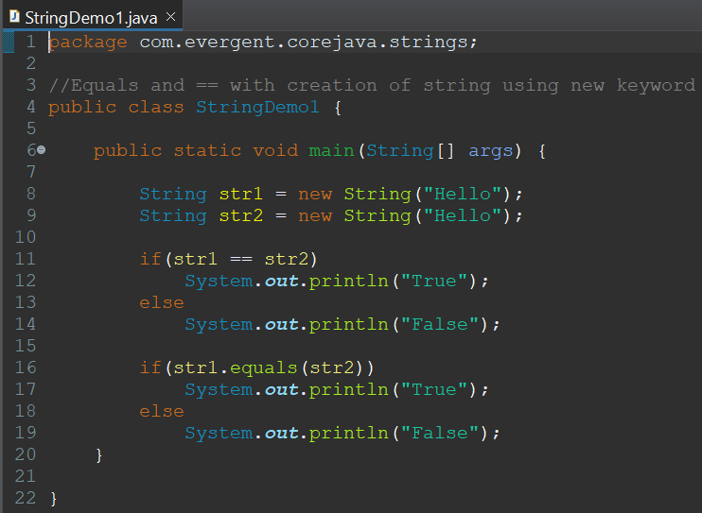

1. In string
   1. equals() is used to compare the content
   2. == is used to compare the memory of the two objects  
      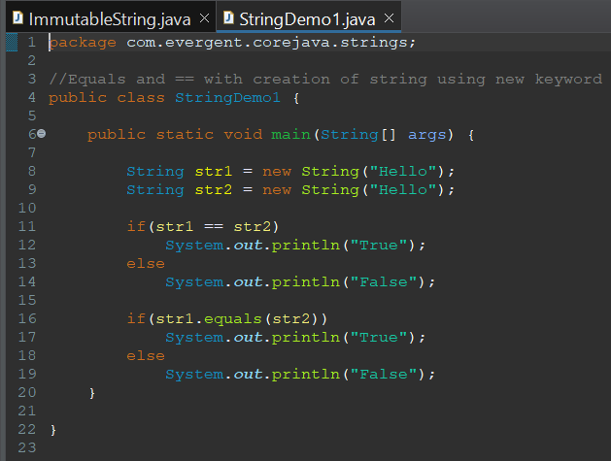

xiii) StringBuffer  
 StringBuffer is a final class.  
 StringBuffer are mutable.  
 String class consists of methods.  
 Methods in StringBuffer class are synchronized.  
1) StringBuffer methods(append()-used to combine the two strings into one String,  
Insert-to insert the string into the present string based on the index value,reverse-to reverse the string ,replace-replace the string with other string based on starting index and ending index,delete-to delete the sub string or string from the existing string based on starting index and ending index.)  
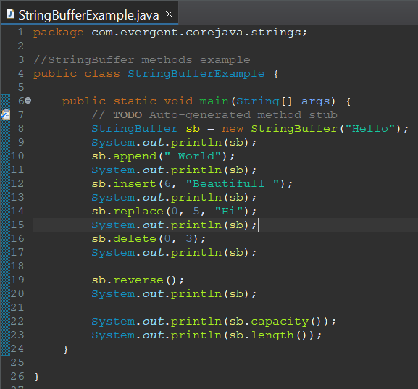

xiv) StringBuilder  
 String Builder is a final class.  
 StringBuilder are mutable.  
 StringBuilder class consists of methods.  
 Methods in String class are non-synchronized.  
2) 1)StringBuilder methods(append()-used to combine the two strings into one String,Insert-to insert the string into the present string based on the index value,reverse-to reverse the string ,replace-replace the string with other string based on starting index and ending Index,delete-to delete the substring or string from the existing string based on starting index and ending index.)

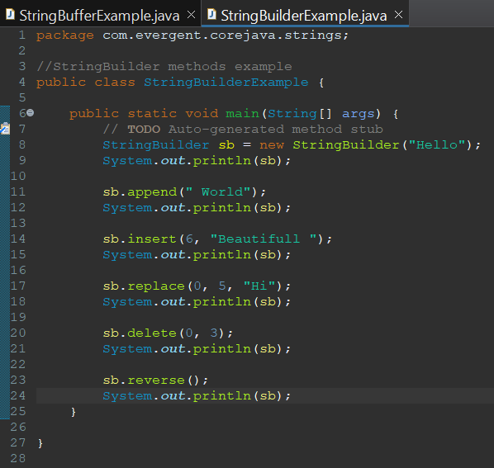

**13/08/2024**

1. **Interface**
2. Interface is keyword
3. We can declare method signature only but not implementation
4. By default all interface methods are abstract
5. If any class implements interface then class should be override all interface methods otherwise the class will be showing compile time error
6. We cannot create object to interface but we can create reference to it
7. We can declare variables inside interface by default they are public static final
8. Java will support multiple inheritance through interfaces
9. One class can implement interfaces
10. One interface can extend interfaces
11. Interface can be created with out methods, these are called as Marker Interface
12. Examples of Marker Interface are cloneable, serializable

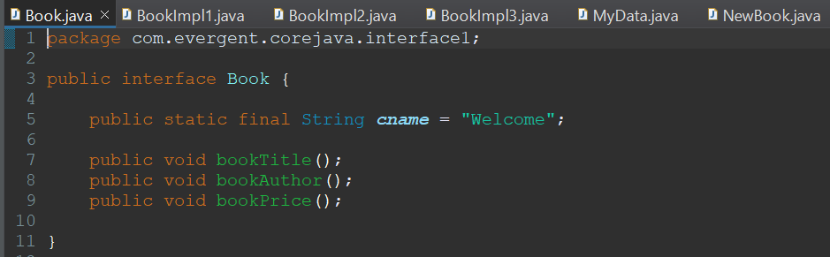

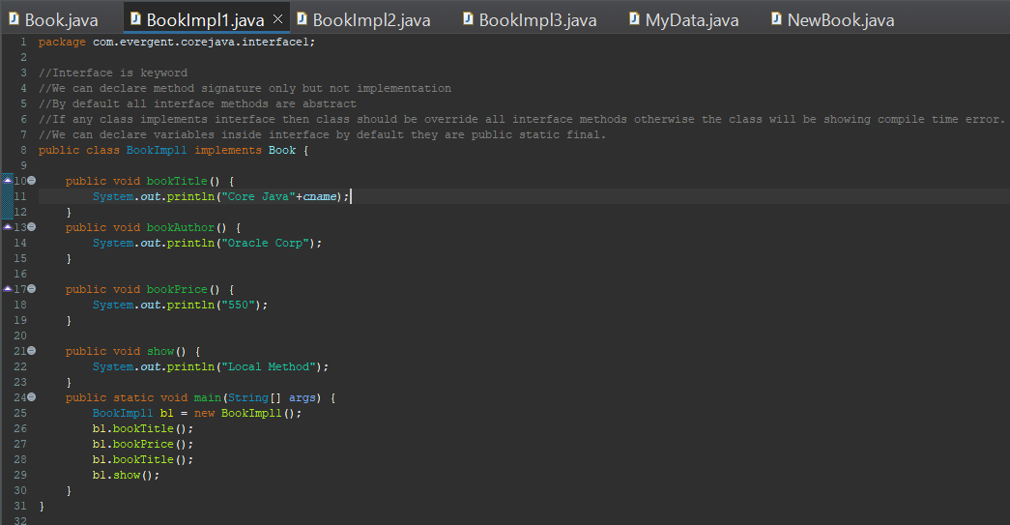

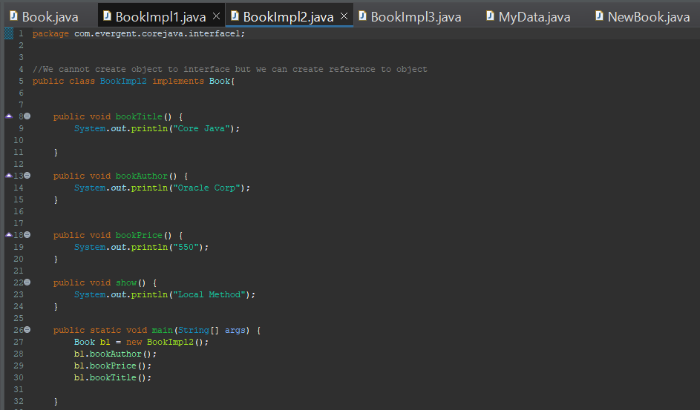

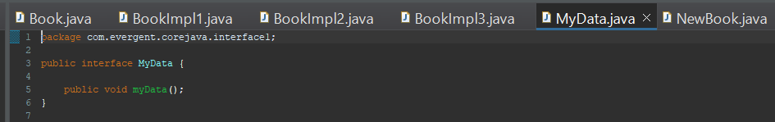

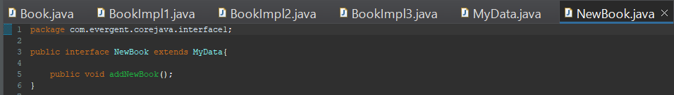

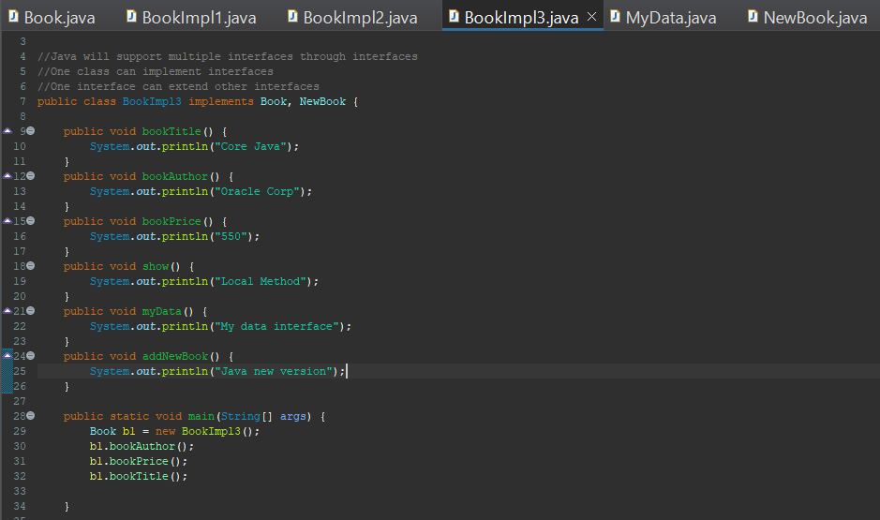

**14/08/2024**

1. **Abstract**
2. Abstract is a keyword
3. Abstract class having abstract methods and concrete(implementation) methods
4. If any class having one abstract method that class should be declared as a abstract otherwise that class will be showing compile time error

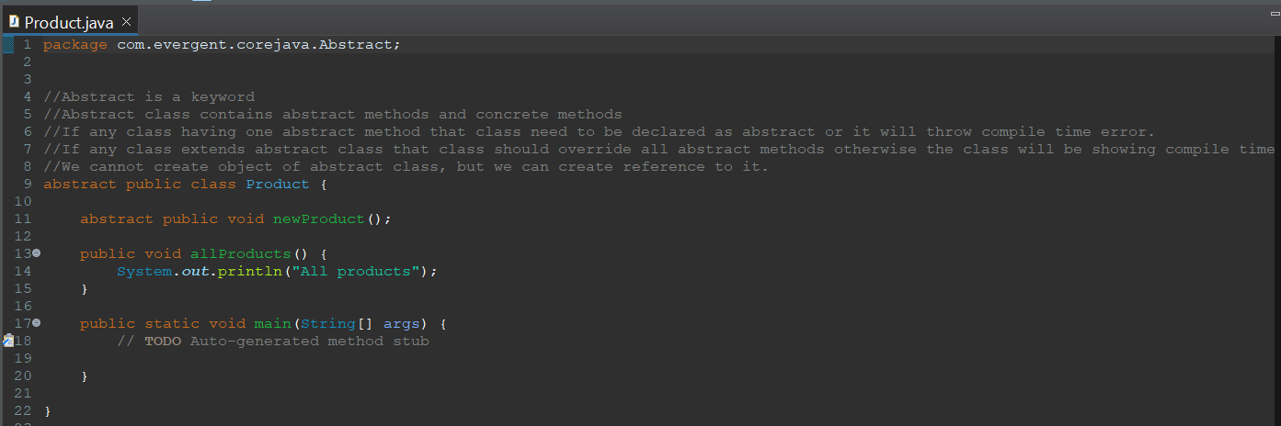

1. If any class extends abstract class that class should be override all abstract methods otherwise the class will be showing compile time error
2. We cannot create object to abstract class, but we can create reference to it.

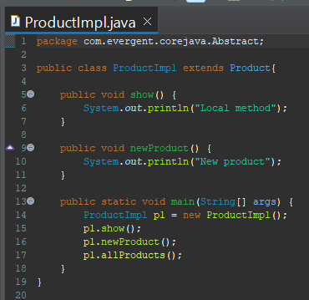

1. Abstract class constructor will be called automatically during object class creation

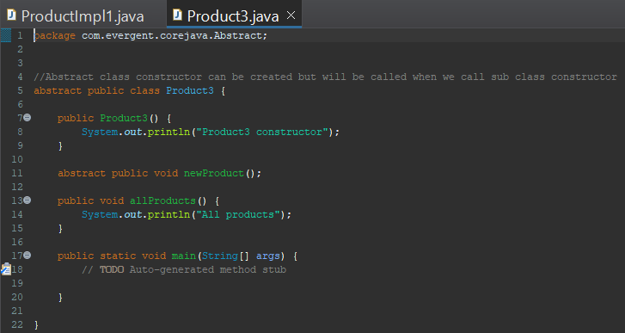

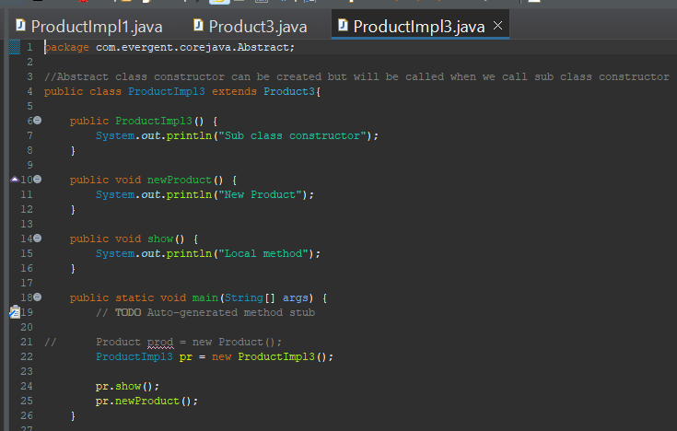

vii. Abstract class constructor can be created but it will be called when we create sub class object.

**19/08/2024**

1. **Exception**
2. Exception handling is a mechanism  
   ii. Exceptions are in built mechanisms of java  
   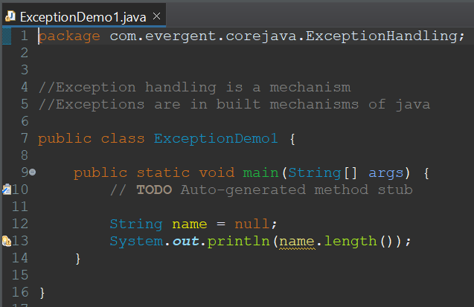  
   iii. All exception are executed while abnormal conditions only  
   iv. It wont execute any exceptions in normal flow  
   v. Once any exceptions are occurring in java code then remaining lines of code is unreachable   
   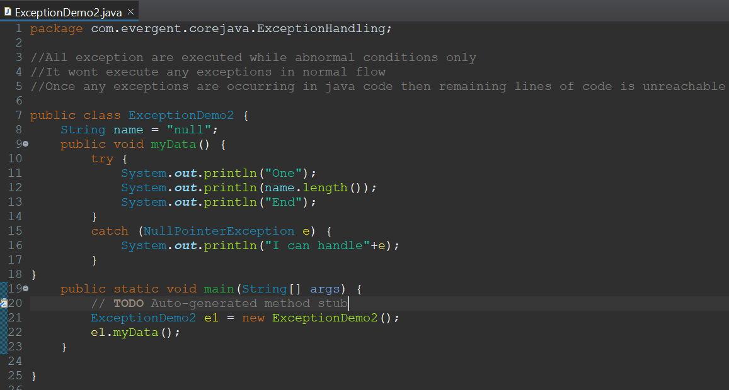  
   vi. Java.lang.Throwable is super class for exceptions and errors  
   vii. There are 2 types of exceptions   
    I. Checked Exceptions  
    II. Unchecked Exceptions  
   viii. All checked exceptions are compile time exceptions  
   ix. All Unchecked exceptions are run time exceptions  
   x. There are 5 keywords in Exception handling  
    I. try  
    II. catch  
    III. finally  
    IV. throws  
    V. throw  
   xi. try is for business logic  
   xii. catch is for handling exceptions  
   xiii. finally is block if exception occurs or not finally block will be executed  
   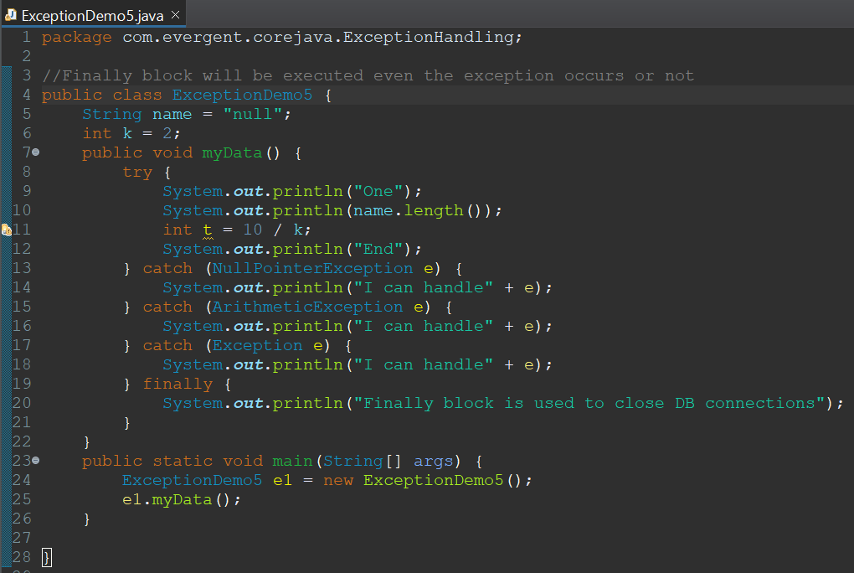  
   xiv. throws an exception is transferred from method to method  
   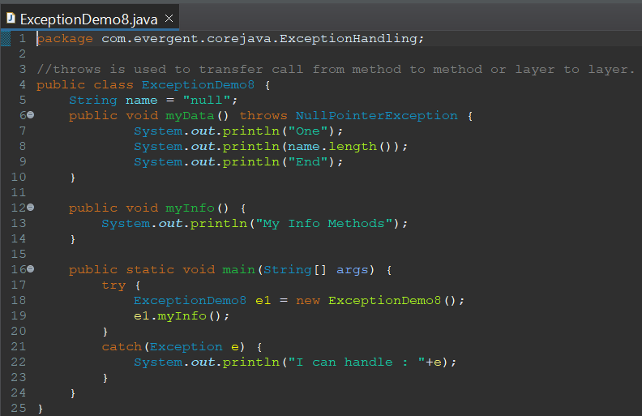  
   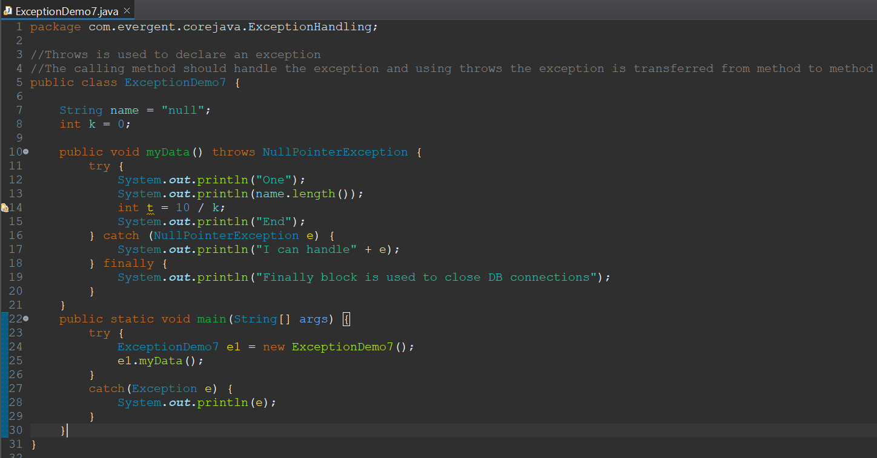  
   xv. throw is for runtime exceptions will call predefined exception classes and user defined exceptions.  
   xvi. Try followed by either catch or final block  
   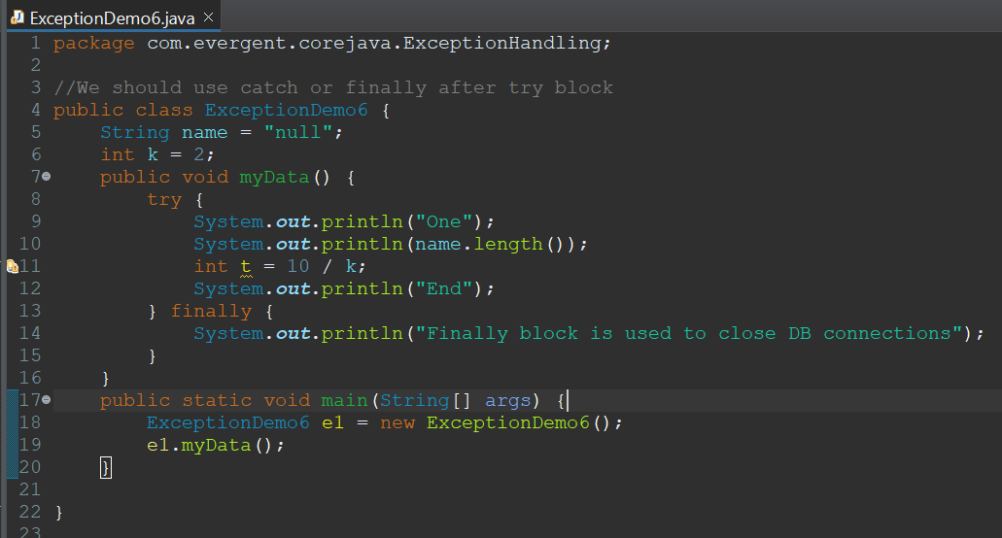  
   xvii. We should follow exception hierarchy  
   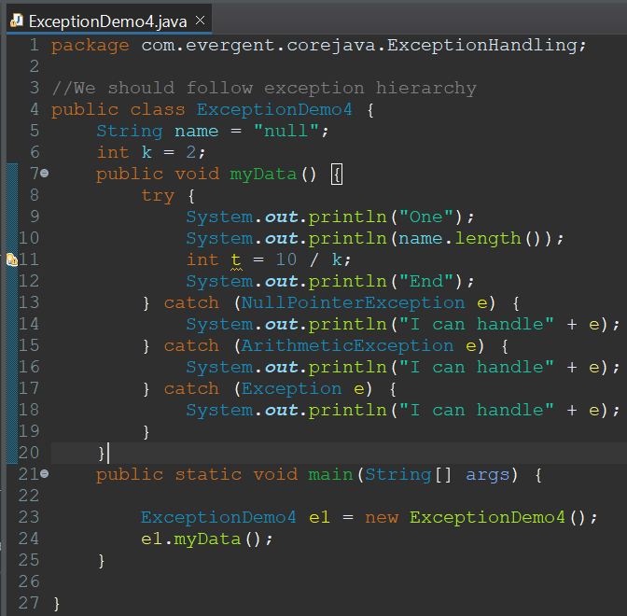  
   xviii. We can create our own user defined exceptions  
   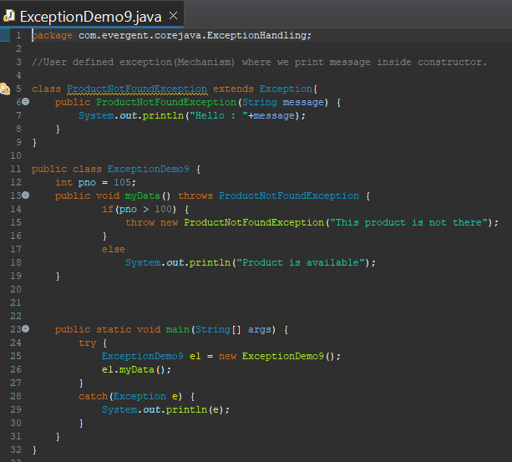  
   xix. Our own exceptions extend Exception or Runtime exceptions  
   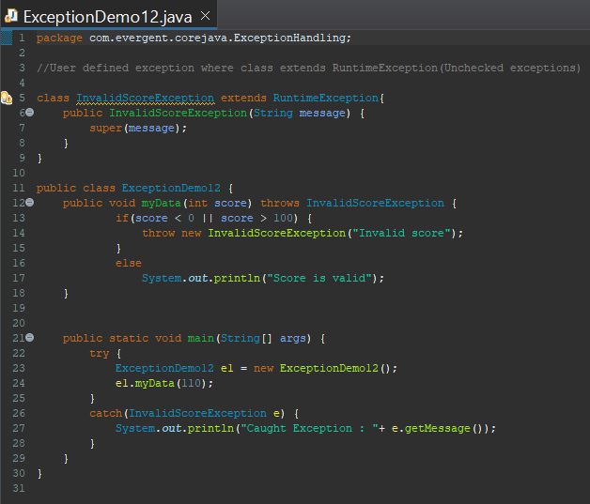  
   xx. All exception classes into java.lang package  
   xxii. If there are 2 exceptions in class developer should handle 1st exception then 2nd exception will be handled next.  
   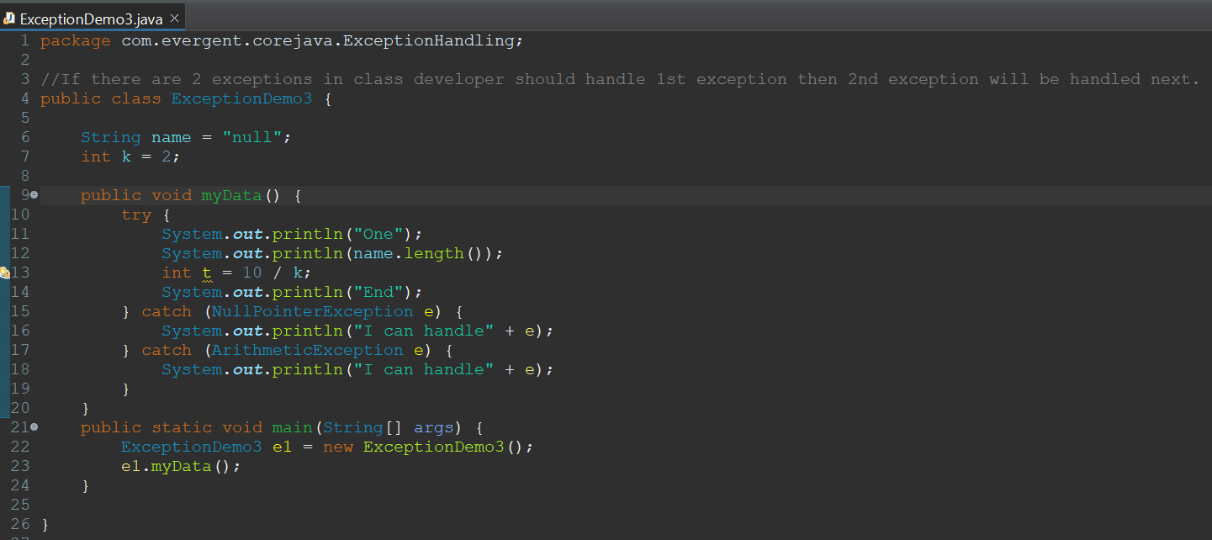  
   xxiii. Errors are not in developer control

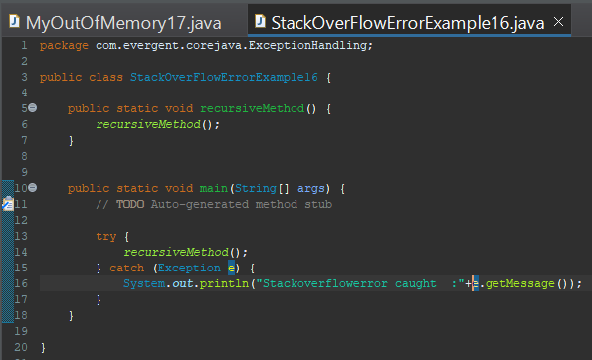

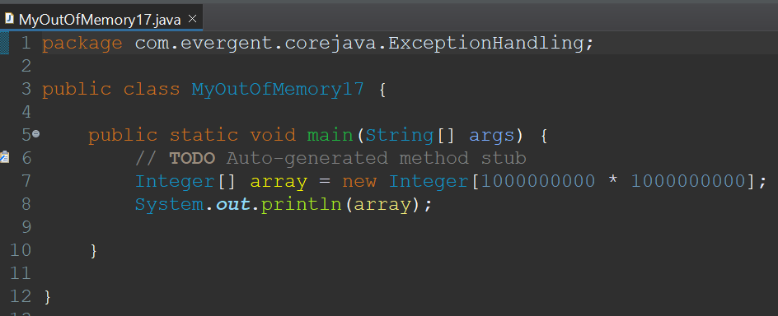

xxiii. We can declare multiple exceptions with throws keyword.  
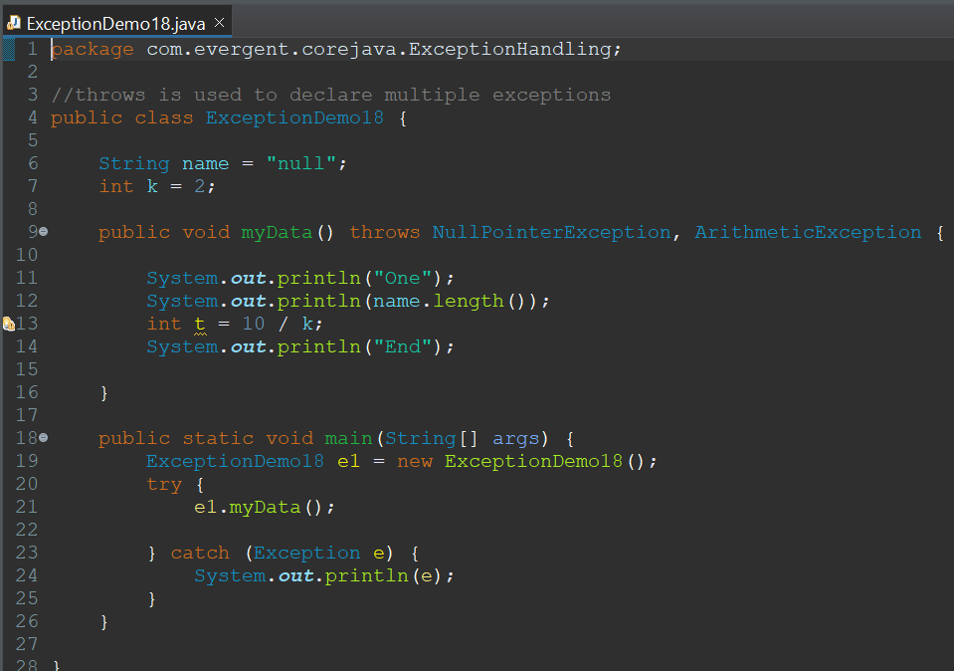

xxiv. We can also use multi catch exception where we put multiple exceptions in catch with OR or pipe symbol.  
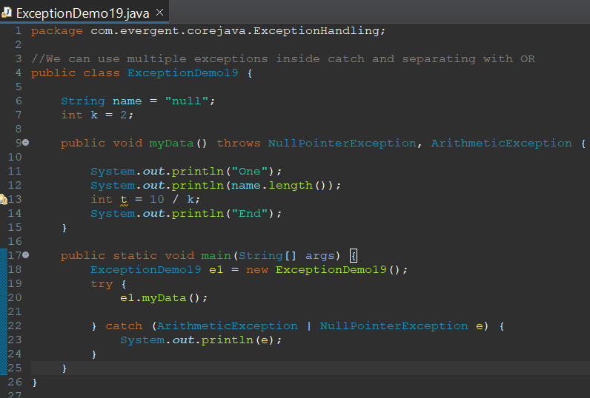

xxv. We can use try inside try called as nested try block.  
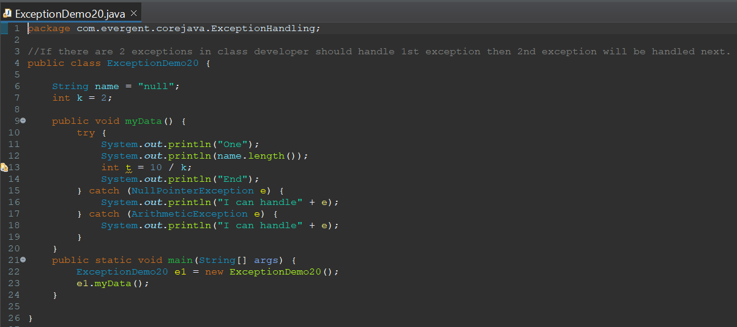

**21/08/24**

1. **Bean**Java bean is mechanism  
   Java bean is lightweight  
   All attributes are private  
   Getters and setters methods are public  
   Implements java.io.serializable  
   We can achieve tightly encapsulation through java beans 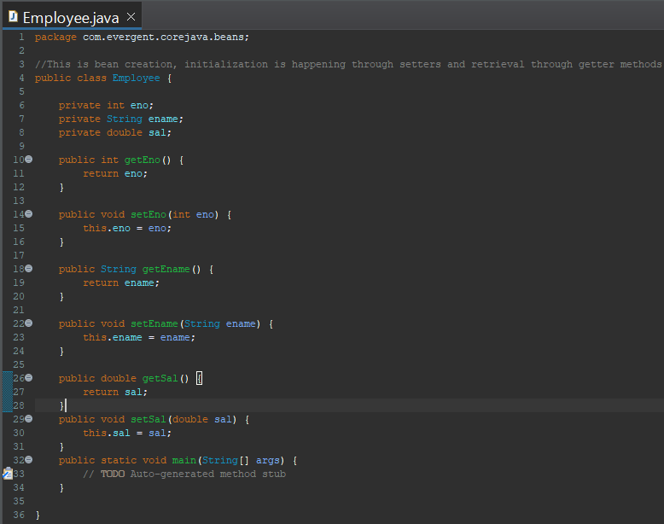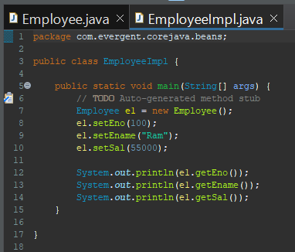

**22/08/24**

1. **Collection Framework**It is predefined structure of different classes and interfaces  
   It is group of classes and interfaces together where we can use their functionality to create our internal implementation or business logic  
   Collection is the root interface
2. **Array List** It is a class which implements list interface  
    Size is growable  
    It supports different data types  
    It contains methods  
    Easy for retrieval operations  
    Default capacity of Arraylist is 10.  
   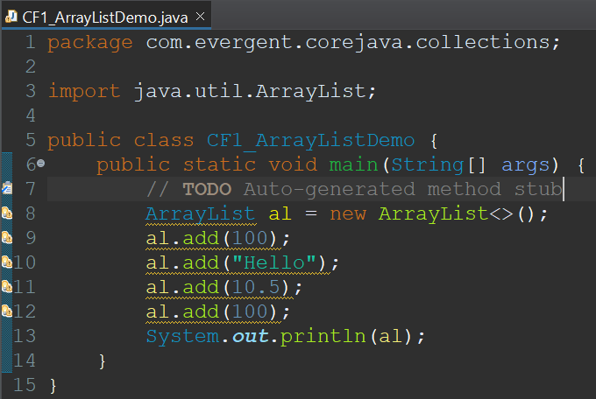

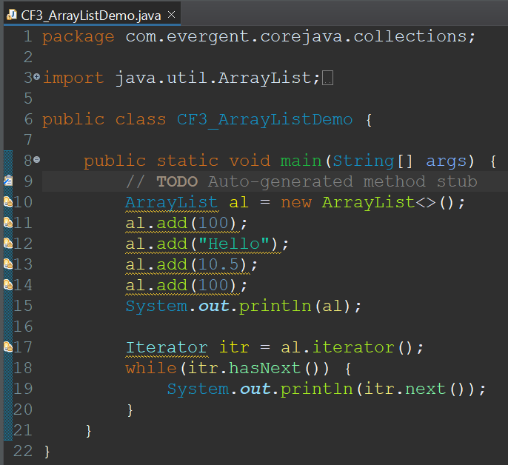

In array list we can store user defined data types  
**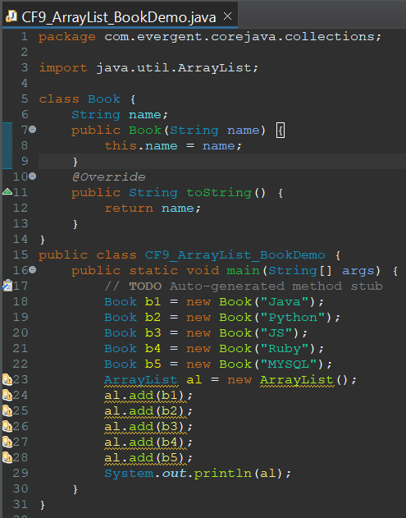  
II. Linked List(Implements List)** It is a class which implements list interface  
 Internally it uses double linked list  
 Size is growable  
 It supports different data types  
 It contains methods  
 Easy for insertion and deletion operations  
**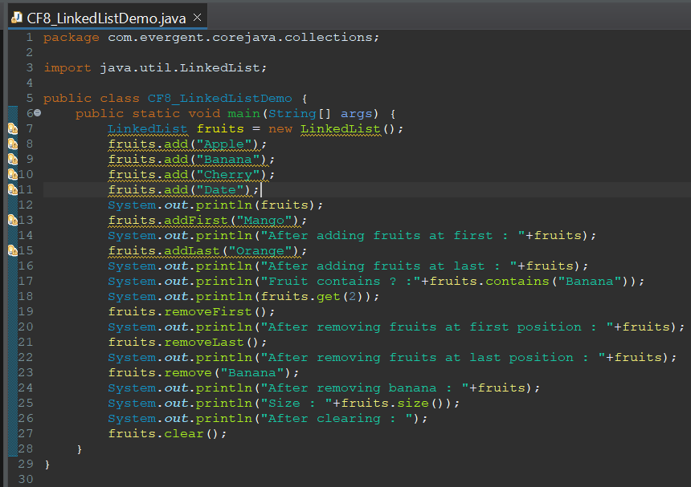  
III. Vector** It is a class which implements list interface  
 It is legacy class(not recommended to use)  
 It is synchronized(thread safe)  
 Size grows double when it reaches it’s threshold value  
**IV. Stack** Stack is First In Last Out(FILO).  
 Stack methods are push(), pop(), search(), clear().  
 Default capacity of Stack is 10.

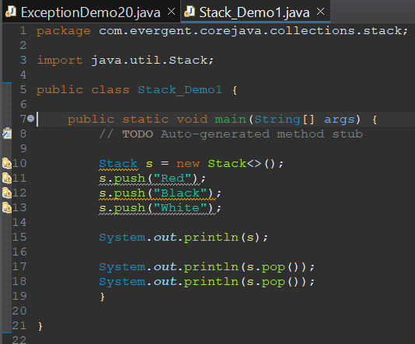

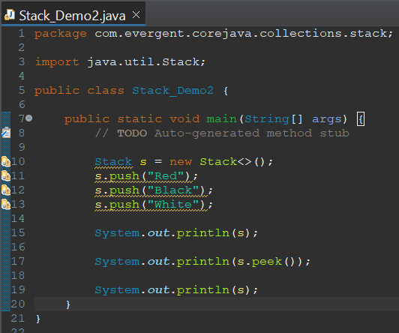

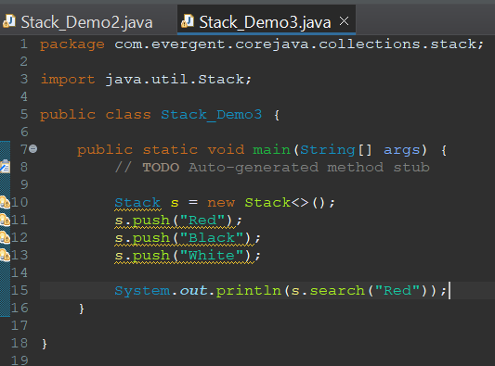

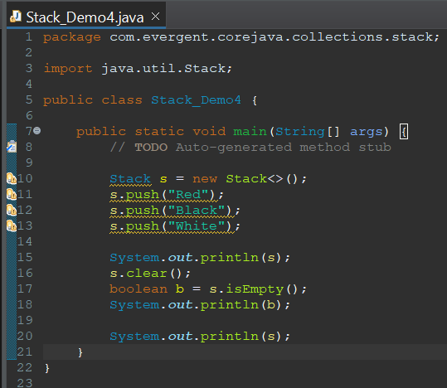

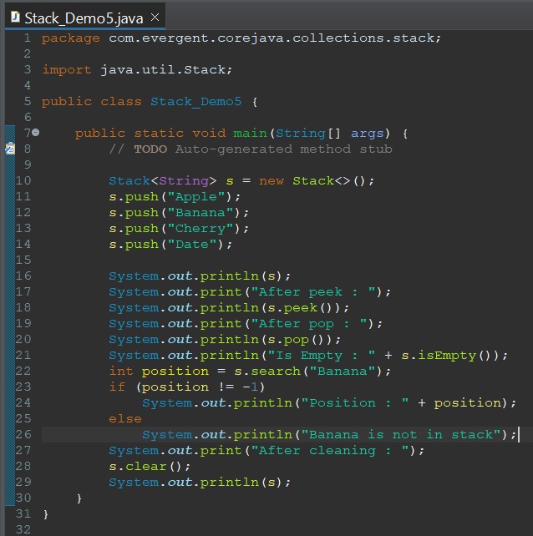



**VI. Hash Set** It is a class which implements set interface  
 It doesn’t allow to store duplicates  
 It stores and retrieves elements in random order  
 Default capacity of hash set is 16  
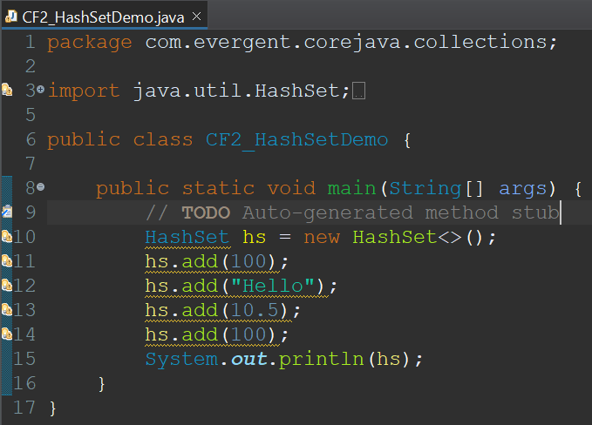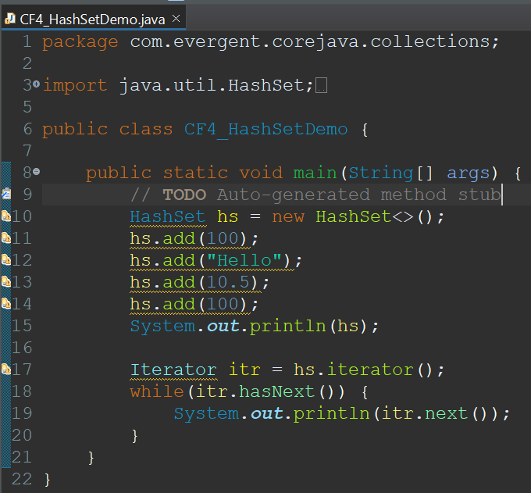

**VII. Tree Set** It is a class which implements set interface  
 It doesn’t allow to store duplicates  
 It stores and retrieves elements in ascending order 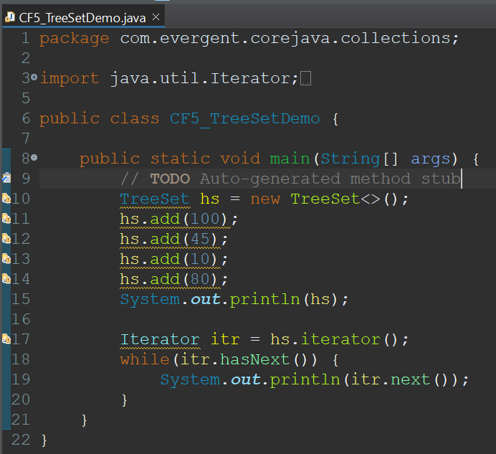

**VIII. Linked Hash Set**Linked Hash set is used to maintain the insertion order.

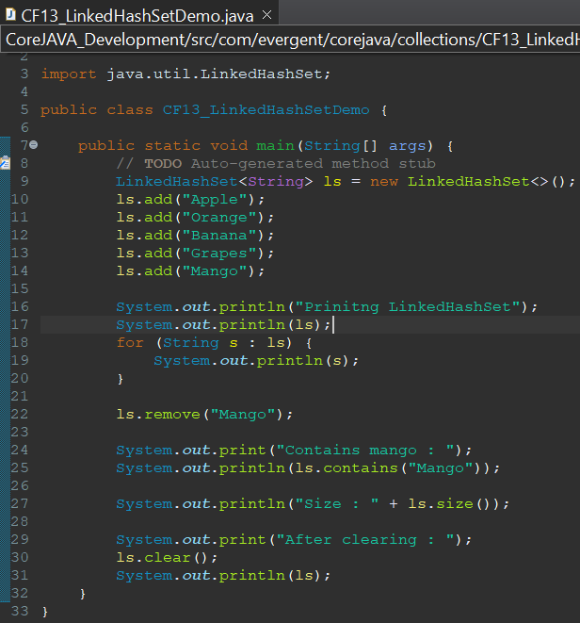

**IX. Priority Queue**It is an interfaceQueue follows First In First Out(FIFO)  
We can add elements from tail and remove elements from head.  
During retrieval it compares with next element and smaller one will be retrieved.  
Default size of Queue is 10.  
Methods used in queue are offer(), poll(), peek() etc.  
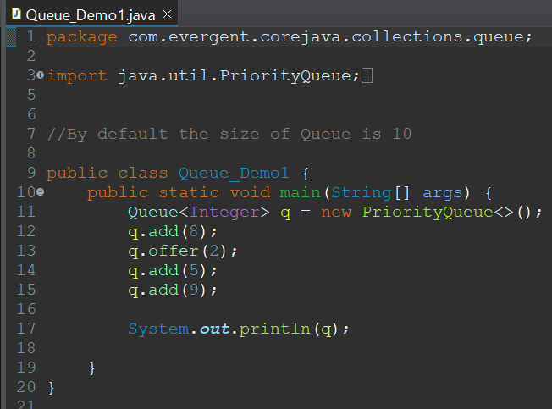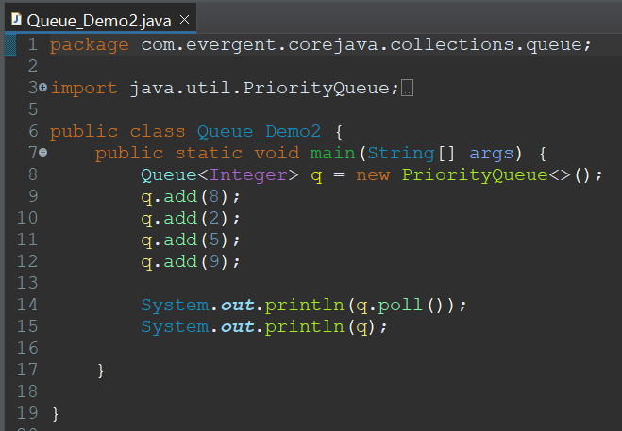

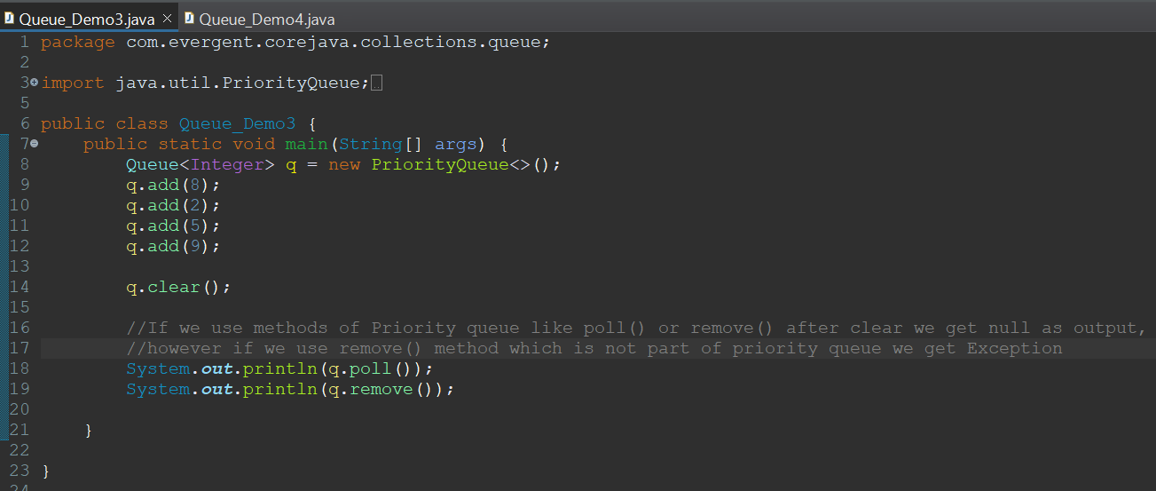

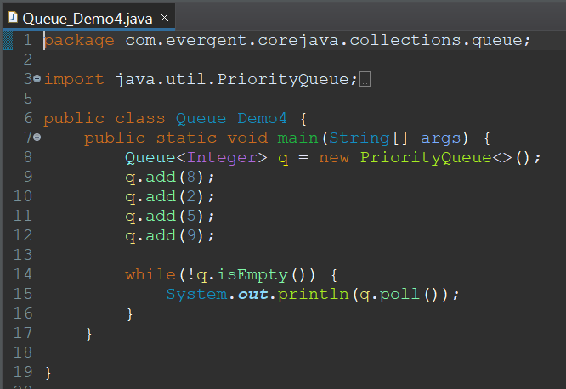

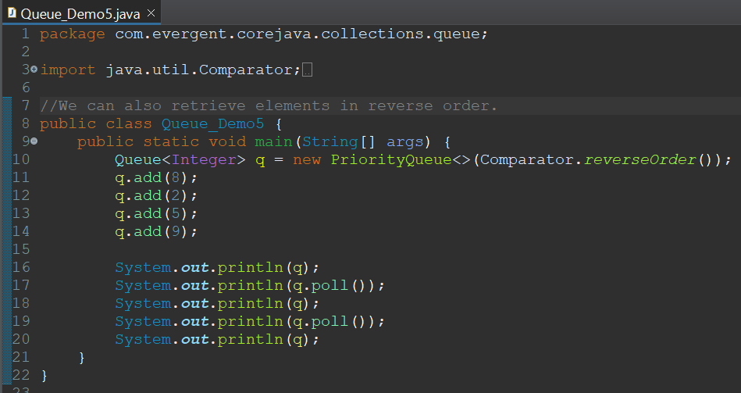

**X. Array Deque**In Array Deque we can insert elements and remove elements from head and tail.  
It follows FIFO principle.  
Methods used in Array Deque are offer(), offerFirst(), offerLast(), poll(), pollFirst(), pollLast(), peek(), peekFirst(), peekLast().  
Default size of Deque is 16.  
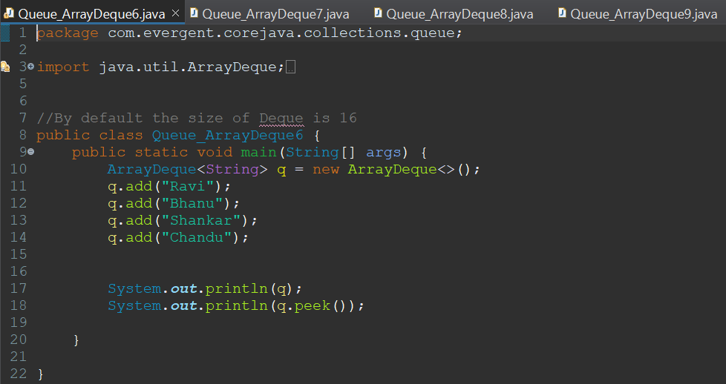

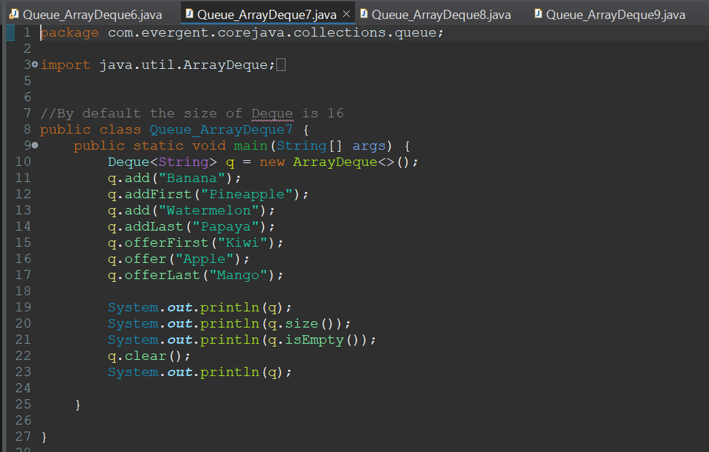

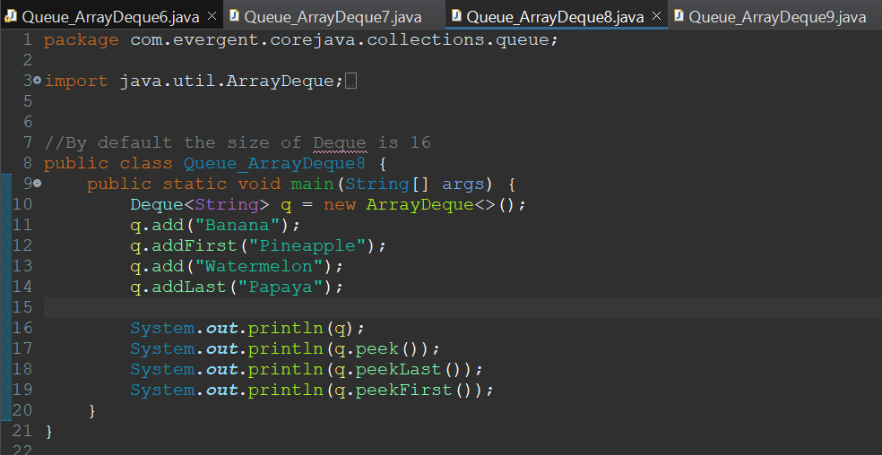

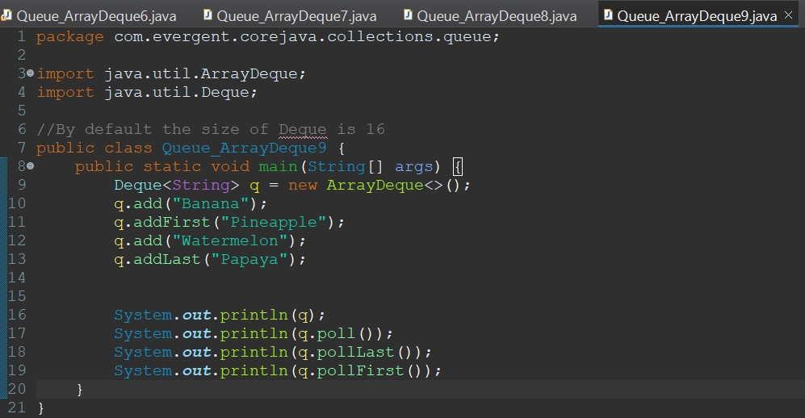

Multi-threading in Queue

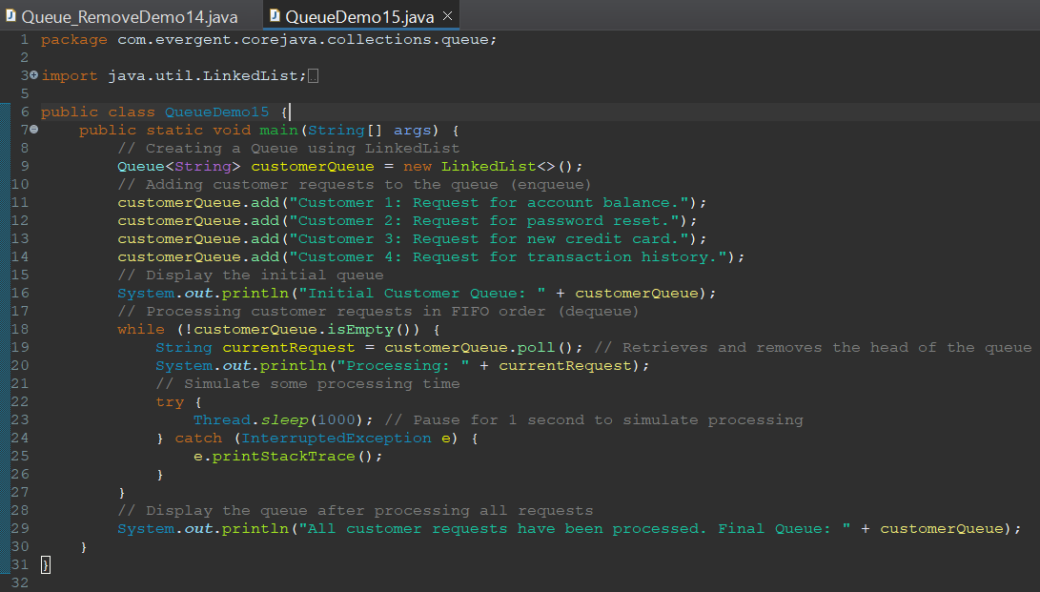

**XI. Linked List(Deque)**It is a class which implements Deque interface  
Internally it uses double linked list  
Size is growable  
It supports different data types  
It contains methods  
Easy for insertion and deletion operations

We can remove elements from linked list using remove() method

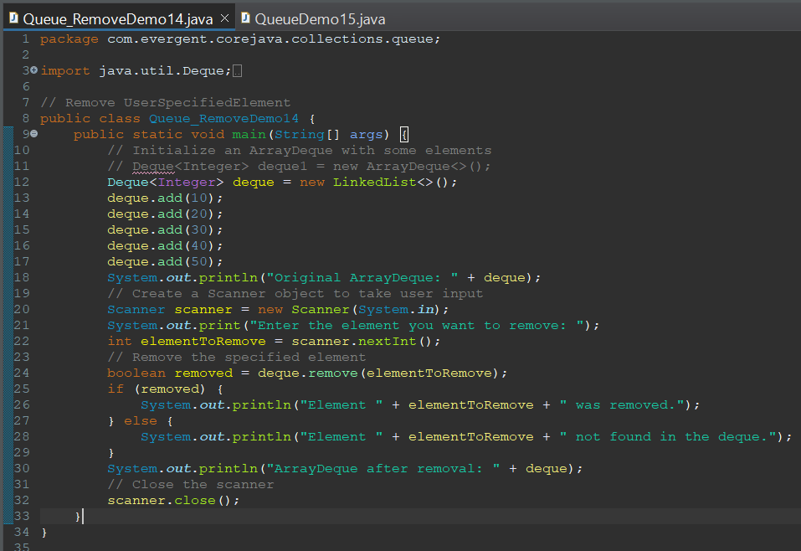

**XII. Hash Table**It stores in key and value pair.Hash table is synchronized  
It doesn’t allow null keys and null values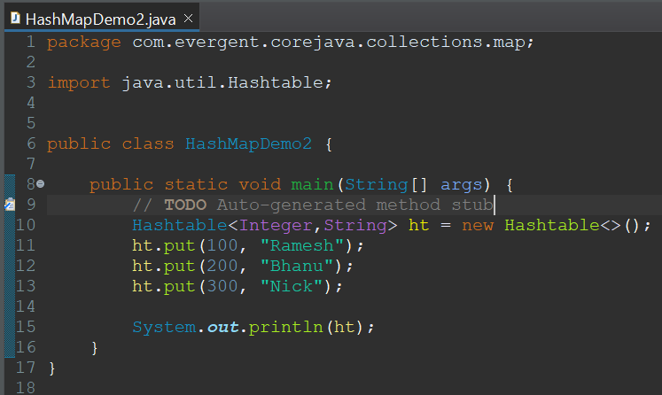

**XIII. Hash Map**

It stores in key and value pair.  
It allows one null key and multiple null values.

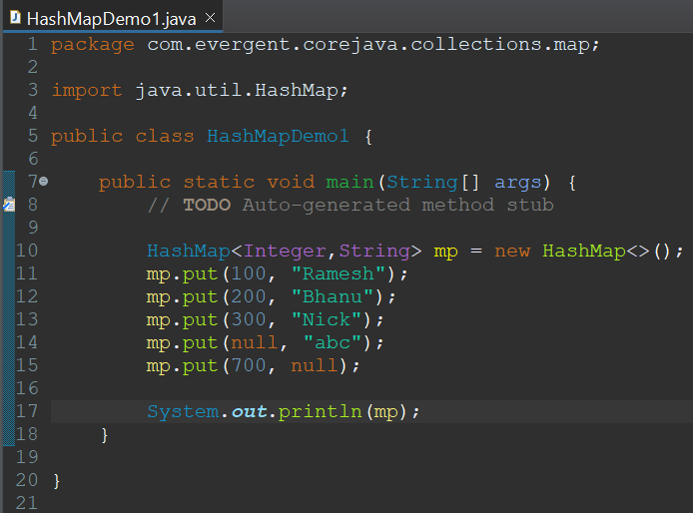

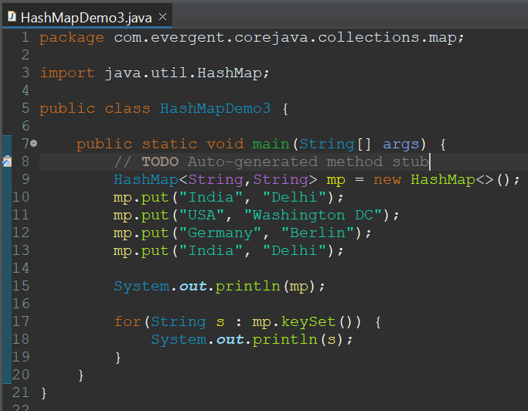

**XIV. Tree Map**

It stores in key and value pair.  
It doesn’t allow null keys however allows multiple null values.

Storing and retrieving will be in sorted order(ascending).

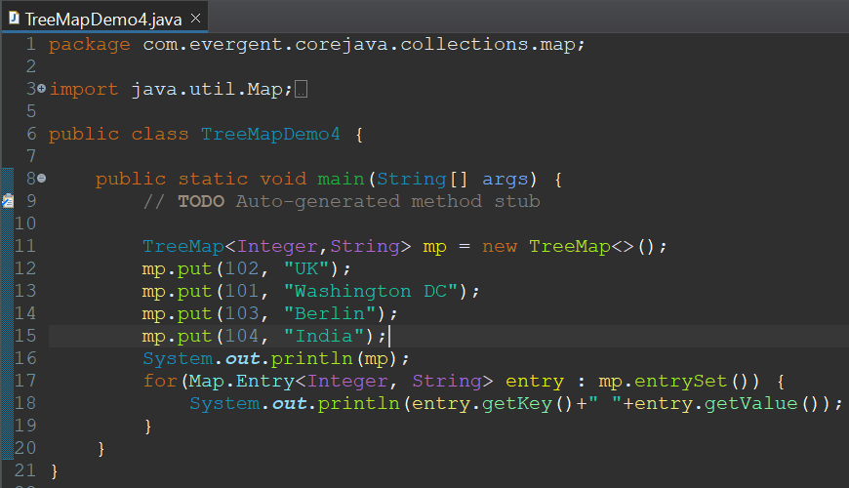

Retrieval of elements from collection framework

1. **Iterator** It is used to retrieve elements in forward direction only  
    We cannot add elements using iterator  
   **II. List Iterator** It is used to retrieve elements in both forward and reverse direction   
    We can add elements using iterator  
   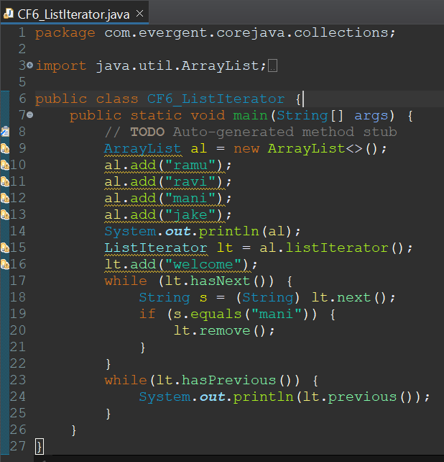  
   **III. Enumeration**  
    It is legacy interface(not recommended to use)  
    It is synchronized(thread safe)  
    It is only used with legacy classes  
    We cannot add and remove elements using enumeration  
   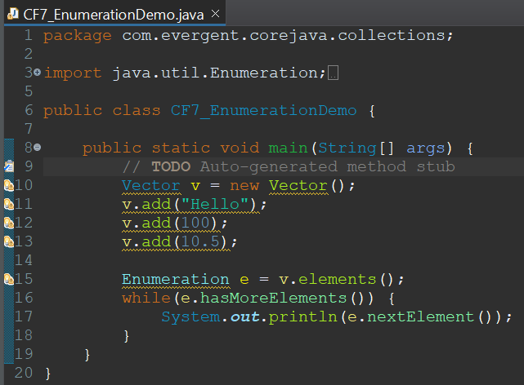

**23/08/24**

1. **Generics**It is used to store only the defined data type elements in collection  
   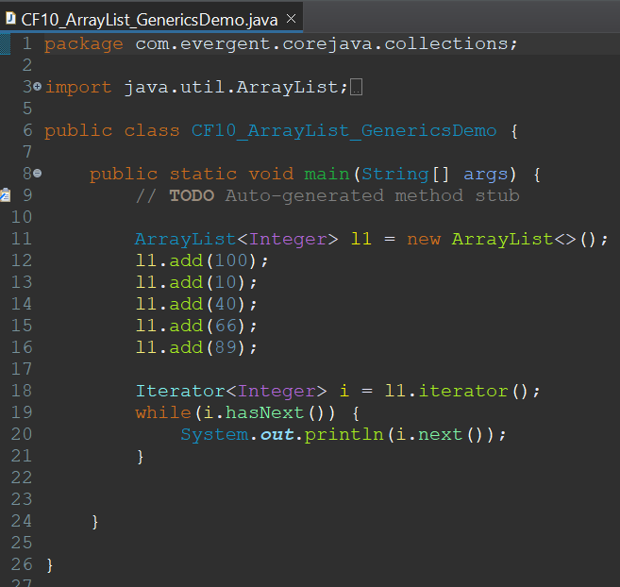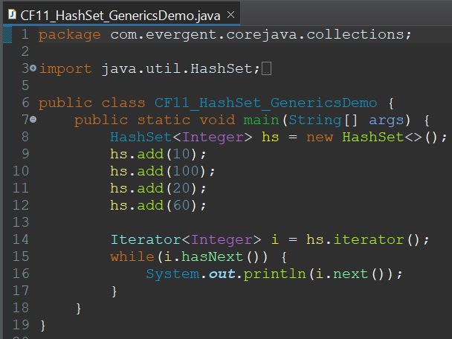
2. **Multithreading**It is defined as execution of multiple threads by reducing the CPU idle time.  
   Thread is a light weight sub process.  
   Threads can be created in 2 ways :-

- By extending thread class  
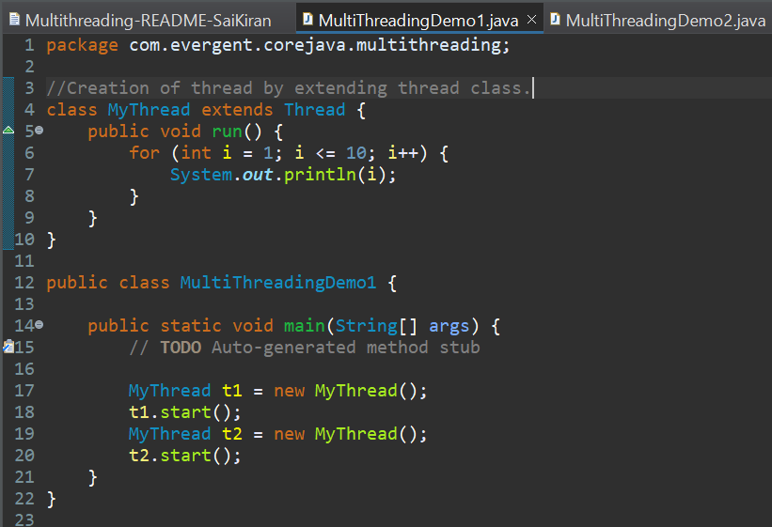

-By implementing runnable interface  
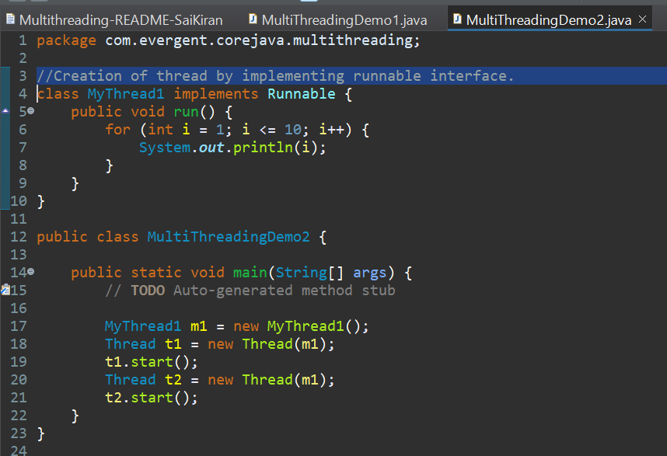  
Synchronization is used to solve data inconsistency problem.

Synchronization is control of access of multiple threads through any shared resource(object), so each thread will perform operations linearly one after other.   
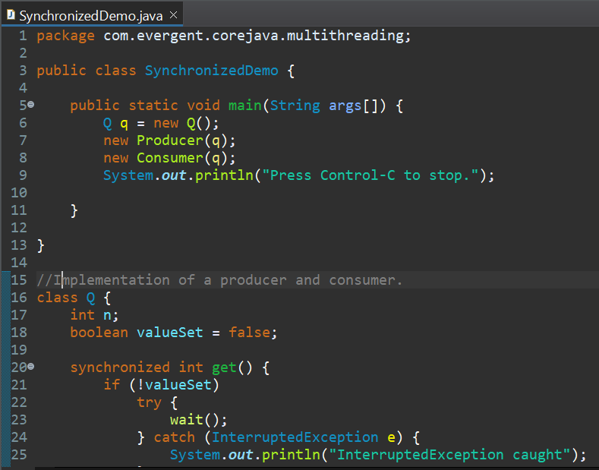

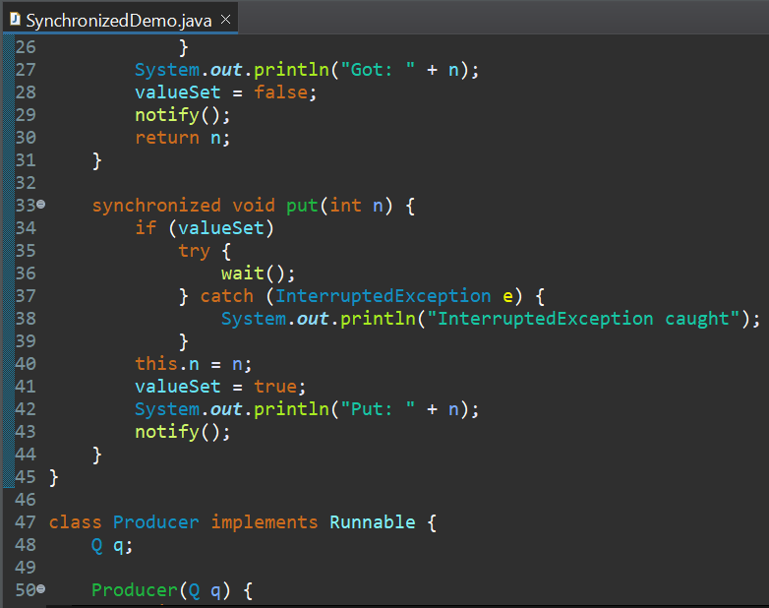

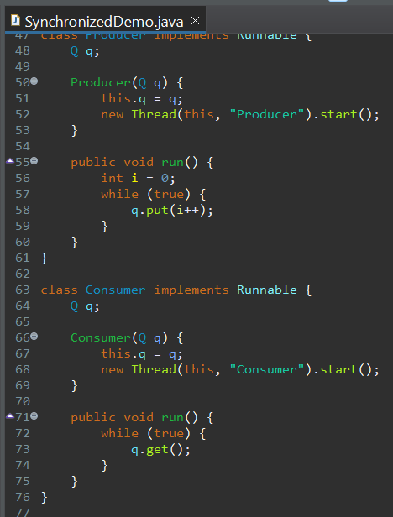

We can achieve synchronization in 2 ways :

- Method level

- Block level   
Methods of thread class :-

- run()

- start()

- isAlive()

- join()

- wait()

- notify()

- notifyAll()

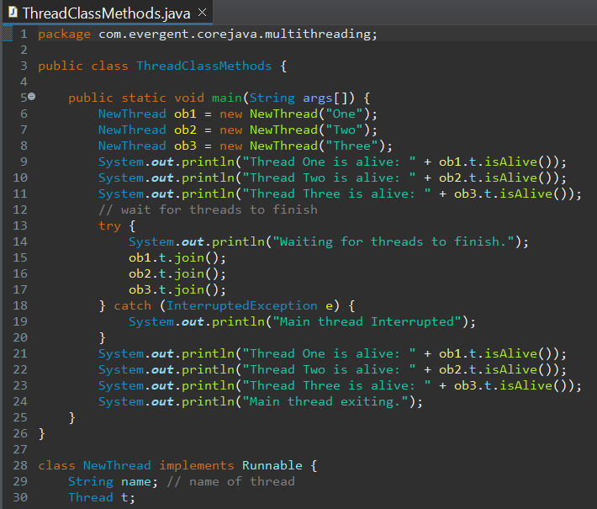

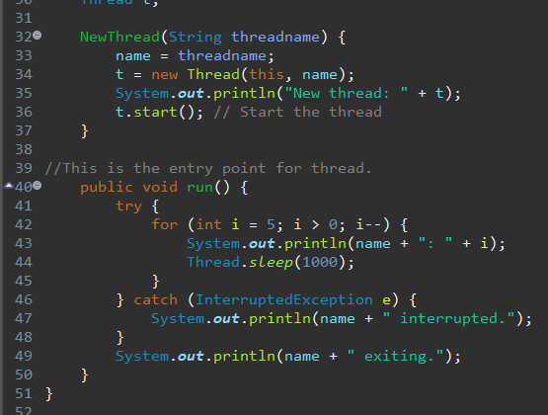

**Thread Methods**

To know name of thread  
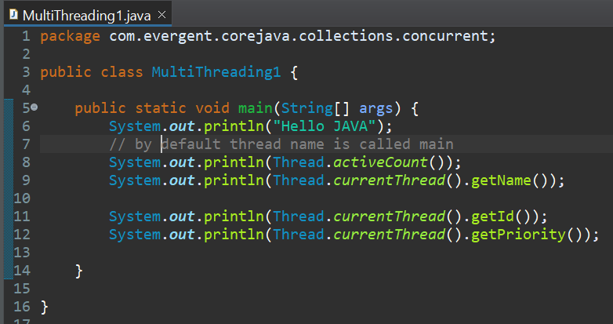

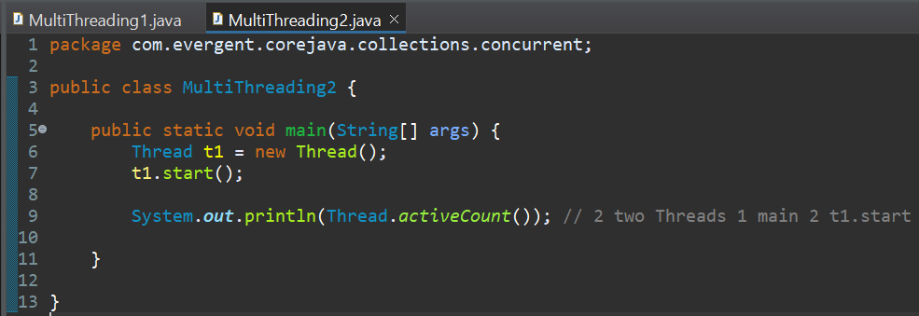

To get active count of thread

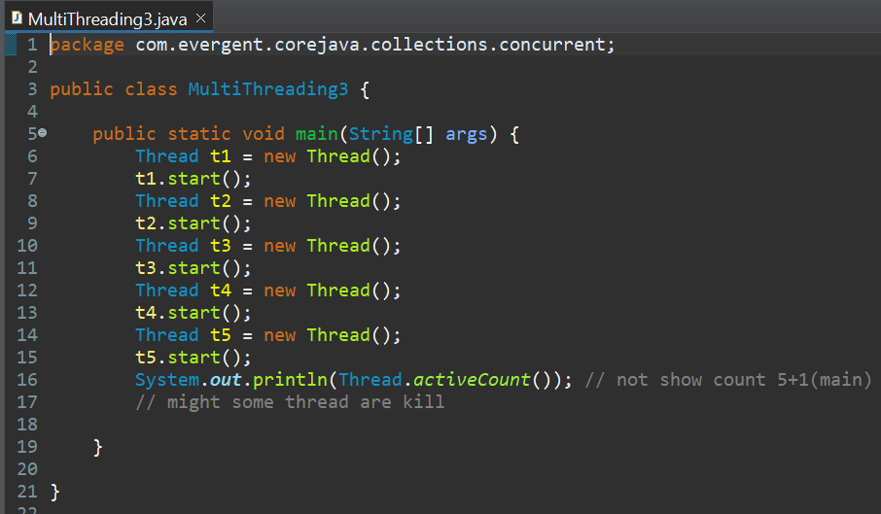

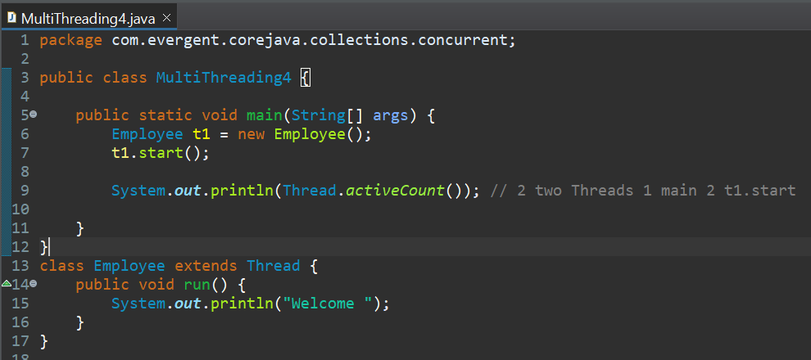

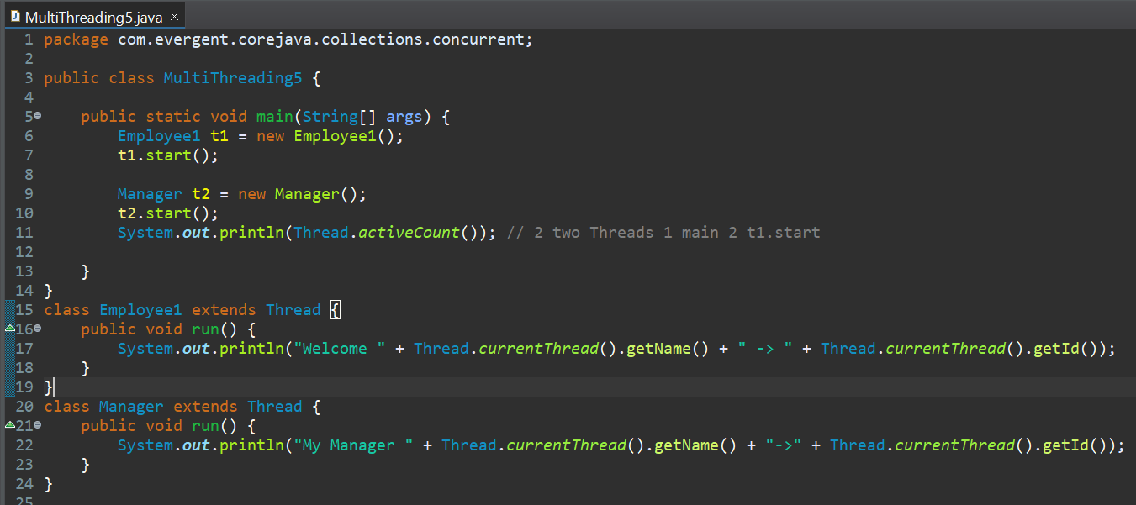

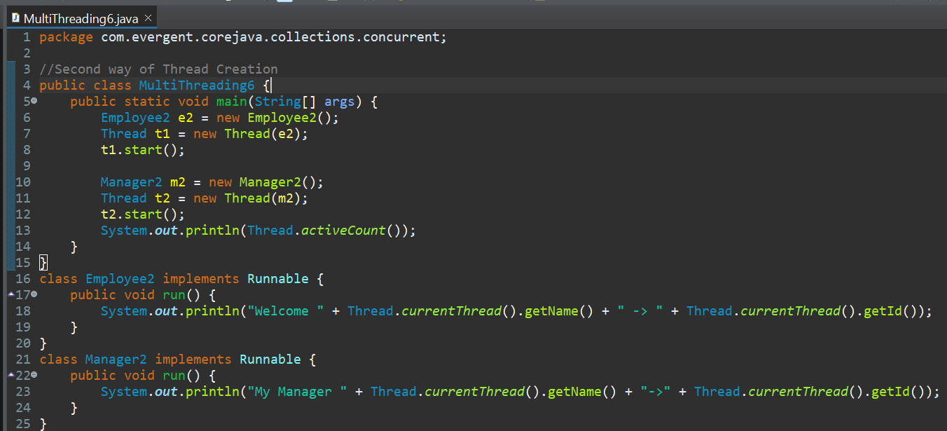

Creating thread using anonymous class.

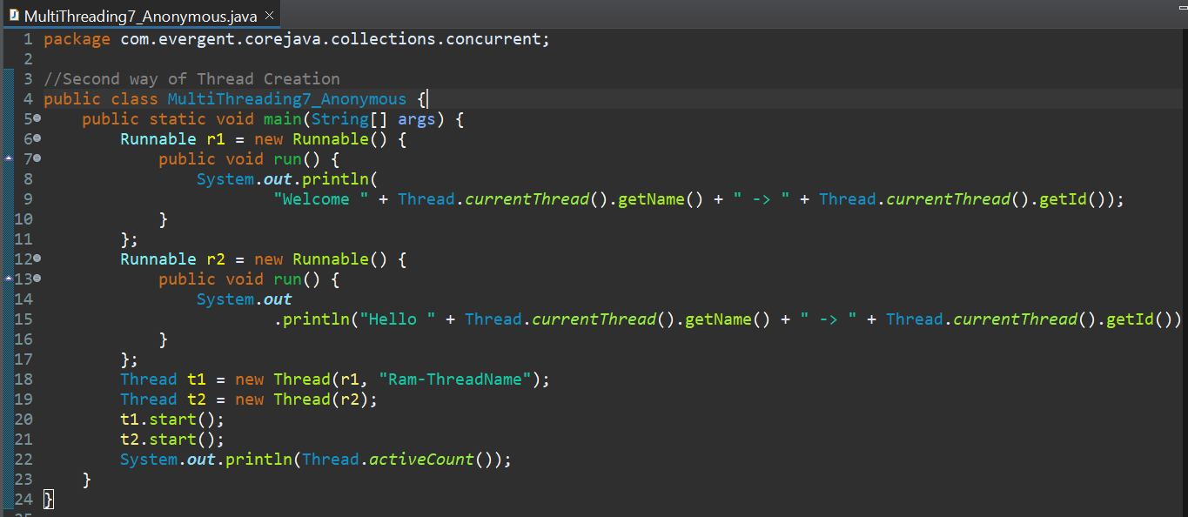

Creating thread using anonymous lambda

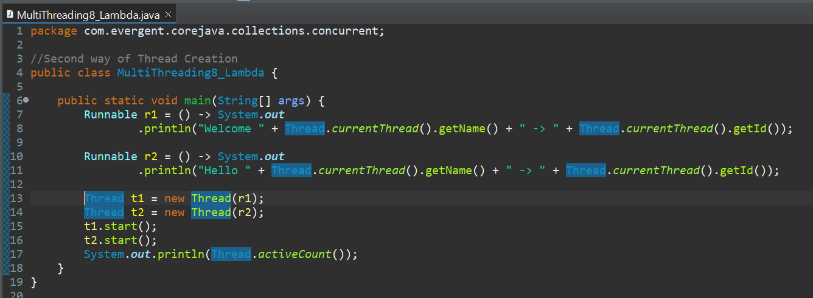

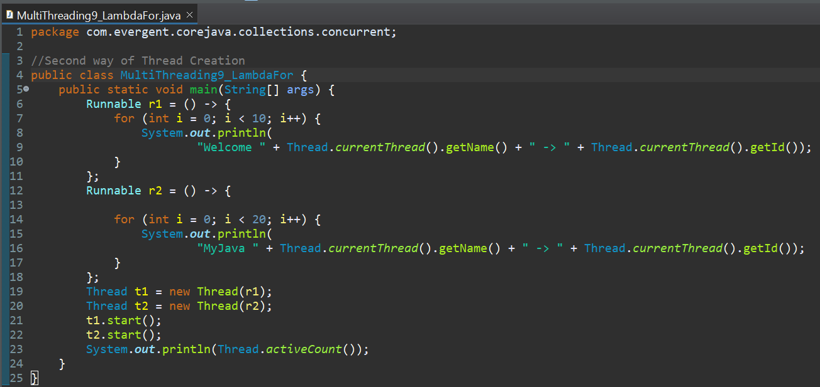

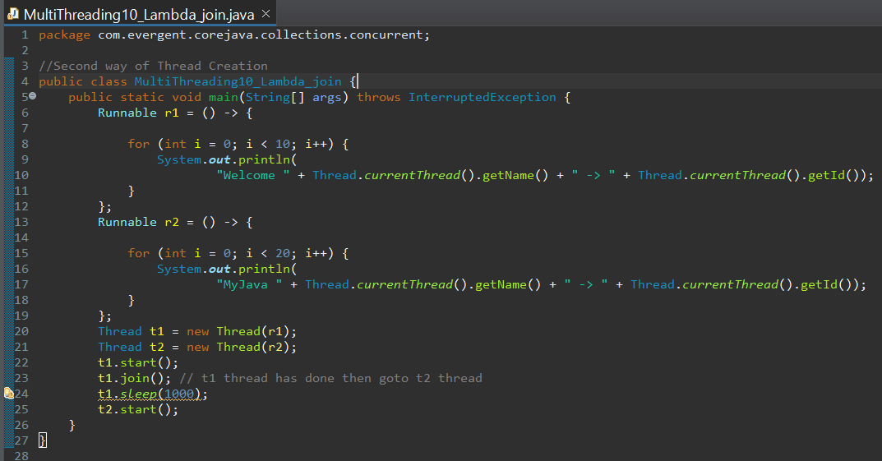

There are 5 different thread states of thread.  
1)NEW  
2)RUNNABLE  
3)RUNNING  
4)BLOCKED  
5)DEAD

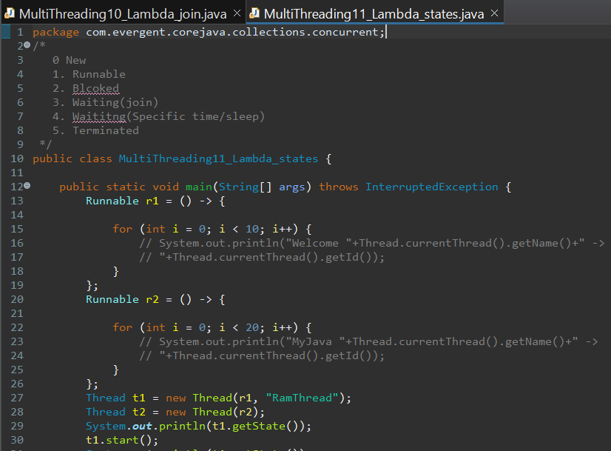

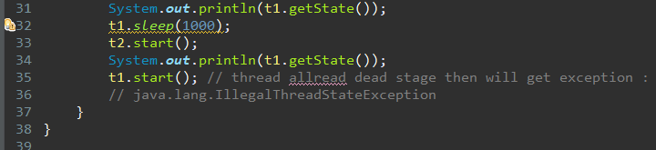

1. **IO Streams**  
   Java I/O (Input and Output) is used to process the input and produce the output.

Java uses the concept of a stream to make I/O operation fast.

File class is used to open a file and if file is not present it throws exception.

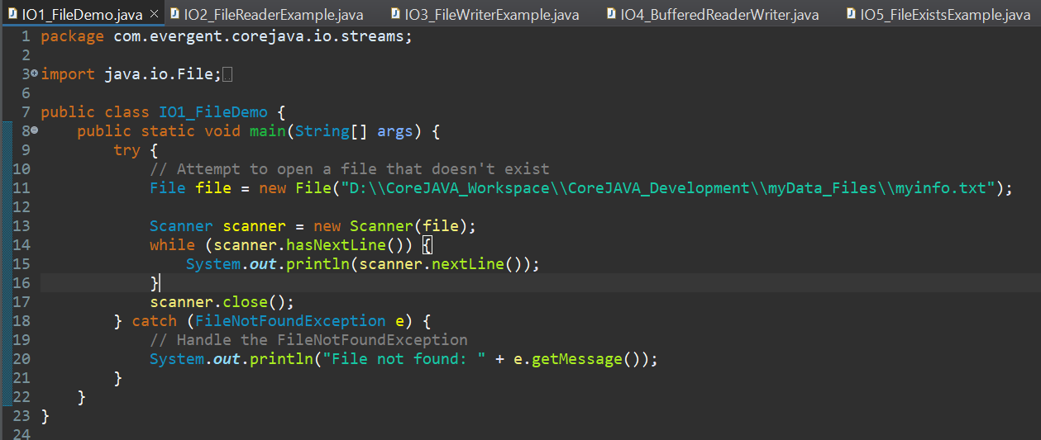

FileInputStream is used to read data from file in form of bytes.  
File reader is used to read data from file in form of characters.

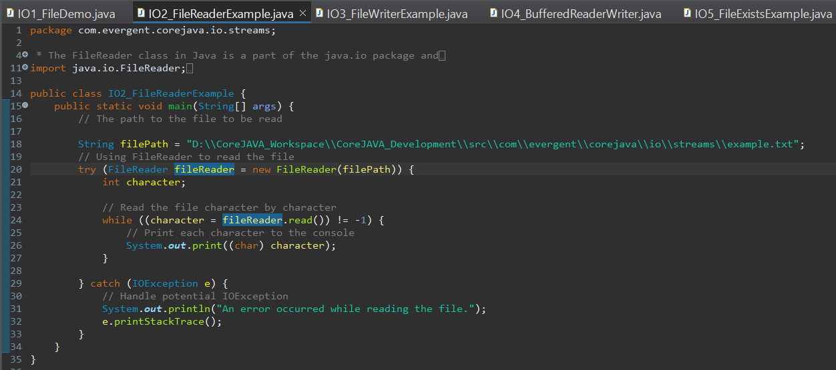

FileOutputStream is used to write data to file in form of bytes.

File writer is used to write data from one file to other file in form of characters.

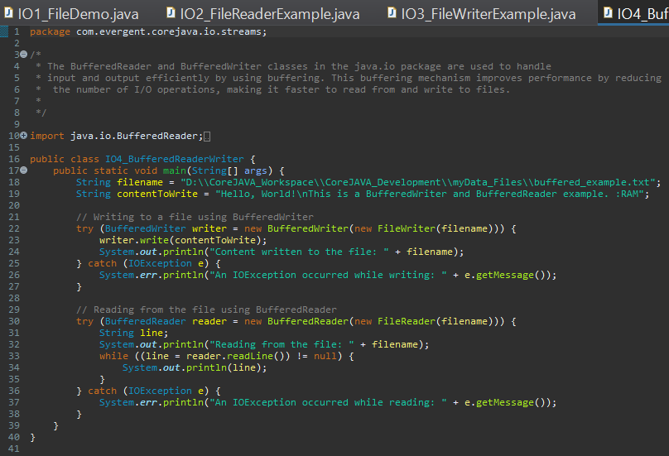

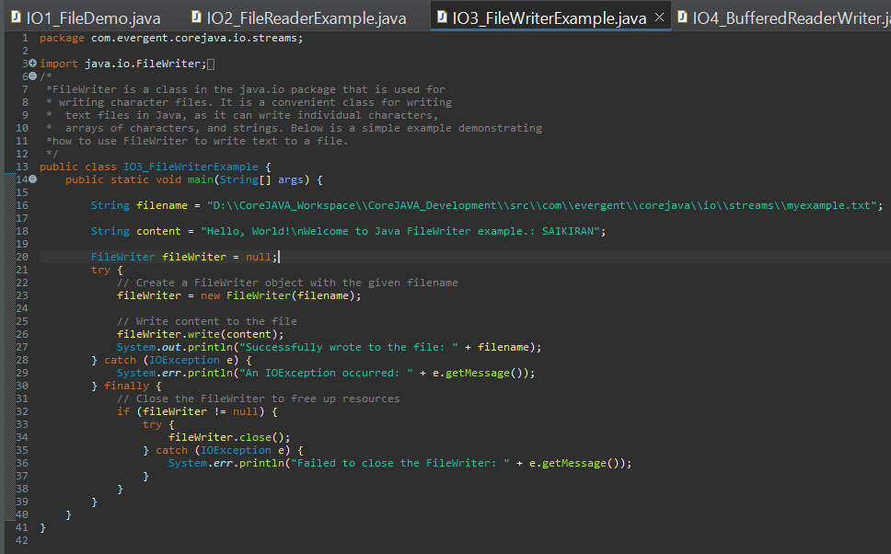

We have Buffered Reader which reduces the no of disk operations, by storing data in buffer then followed by writing to disk or reading from disk.

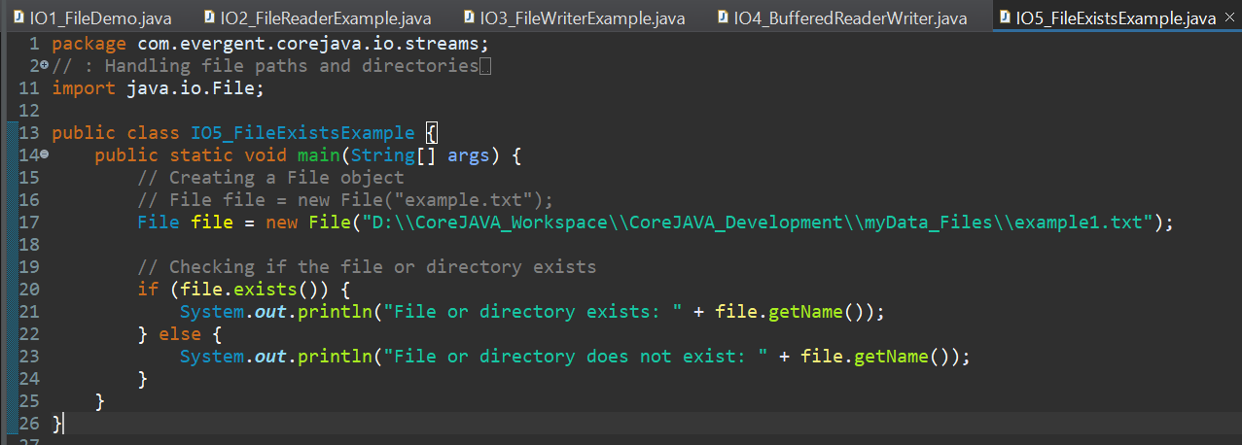

1. **NIO  
   -** Java IO(Input/Output) is used to perform read and write operations.

- The java.io package contains all the classes required for input and output operation.

- Whereas, Java NIO (New IO) was introduced from JDK 4 to implement high-speed IO operations.

- It is an alternative to the standard IO API’s.

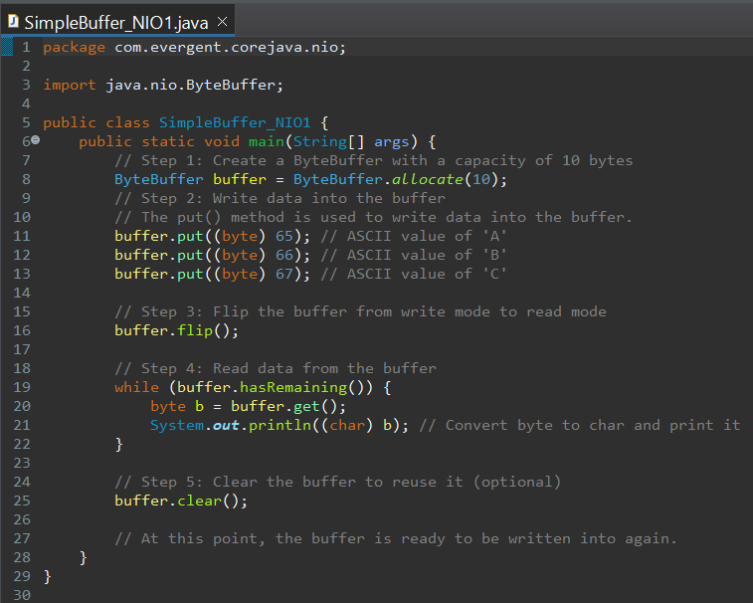

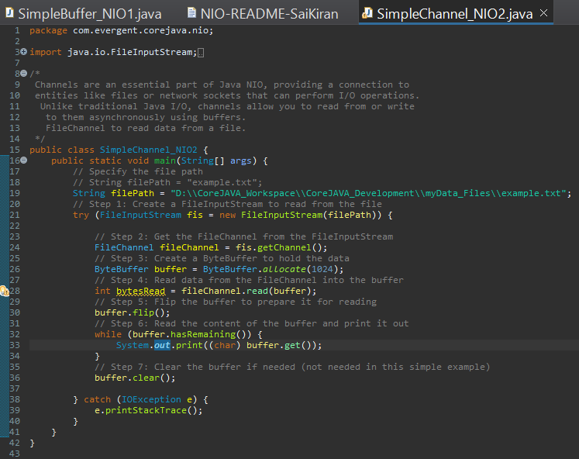

1. **Concurrency Multi Threading**

Executor Service

1. execute()

2. shutDown() // shutting down after completion

3. awaitTermination()

4. Future

5. submit (new Runnable())

6. submit(new Callable())

Executor Framework in Java

1. The Executor Framework in Java is a powerful tool for managing concurrent execution.

2. It provides a flexible and efficient way to submit tasks for asynchronous execution,

control the lifecycle of these tasks, and handle the results.

3. The Executor is a simple interface provided in the java.util.concurrent package.

4. The Executor interface contains only one method, execute(Runnable command),

which takes a Runnable object as an argument. The Runnable defines the

task to be executed.

ExecutorService is an interface in Java's java.util.concurrent package that

provides a framework for managing and controlling threads, allowing you

to execute tasks asynchronously without manually handling the creation

and management of individual threads.

ExecutorService in the java.util.concurrent package, which is a part of

Java's concurrency

framework.

1. execute(Runnable command):

This method is used to submit a task for execution.

It takes a Runnable object and executes it asynchronously.

The method doesn't return any value.

2. shutdown():

This method initiates an orderly shutdown of the ExecutorService.

No new tasks are accepted, but previously submitted tasks continue to

execute until completion.

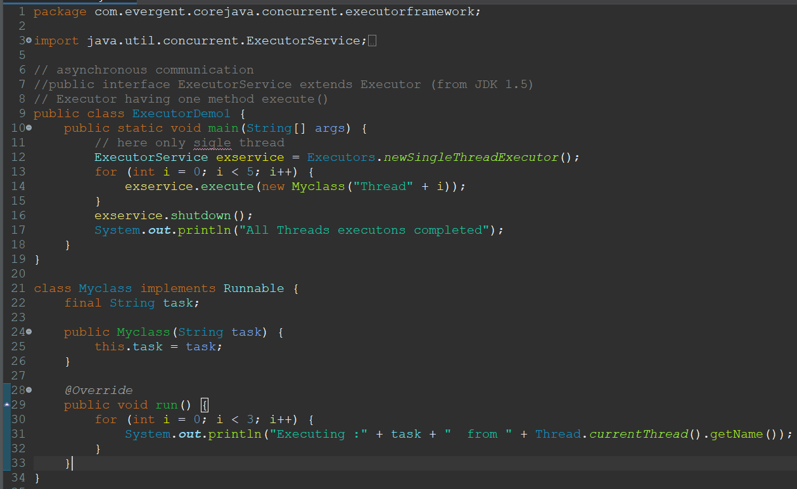

3. awaitTermination(long timeout, TimeUnit unit):

After calling shutdown(), this method blocks until all tasks have completed execution,

or the timeout occurs, or the current thread is interrupted. It takes the timeout and

the time unit as parameters.

4. Future<V>:

This interface represents the result of an asynchronous computation.

It provides methods to check if the task is complete, to wait for the result,

and to cancel the task.

"computation" refers to the process of information processing, where data

is manipulated,

5. submit(Runnable task):

This method submits a Runnable task for execution and returns a Future<?>

representing the task.

Since Runnable doesn’t return a result, the Future will return null on get().

6. submit(Callable<V> task):

This method submits a Callable task for execution and returns a Future<V>

representing the result of the task.

A Callable can return a result, unlike Runnable.

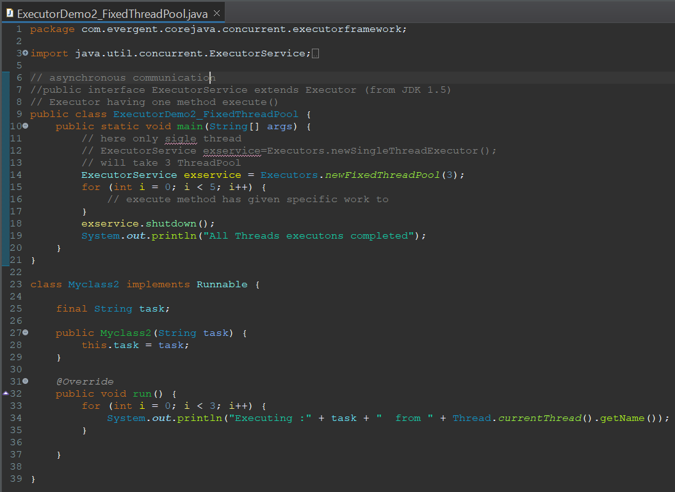

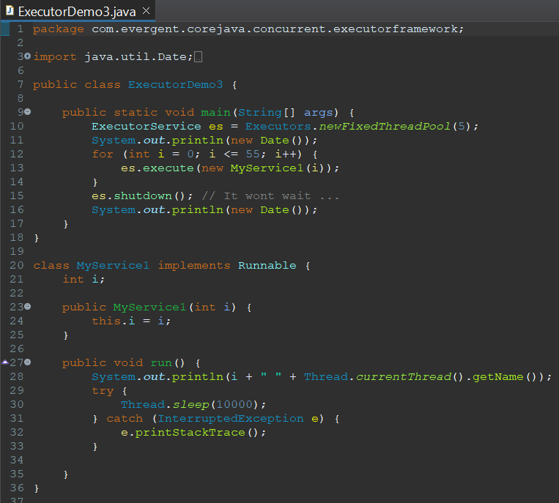

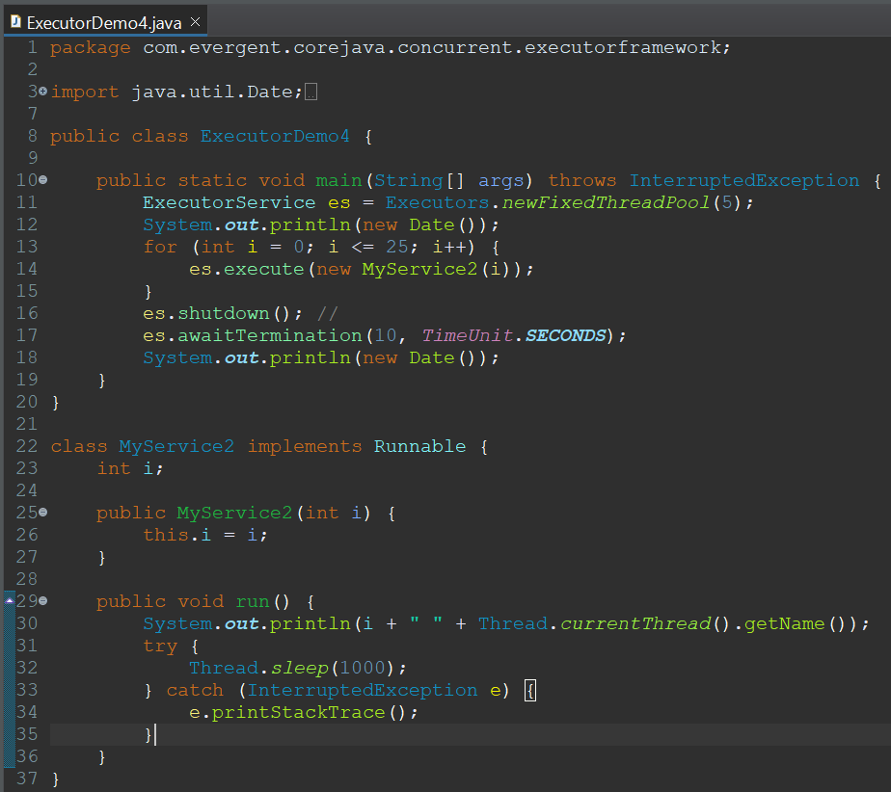

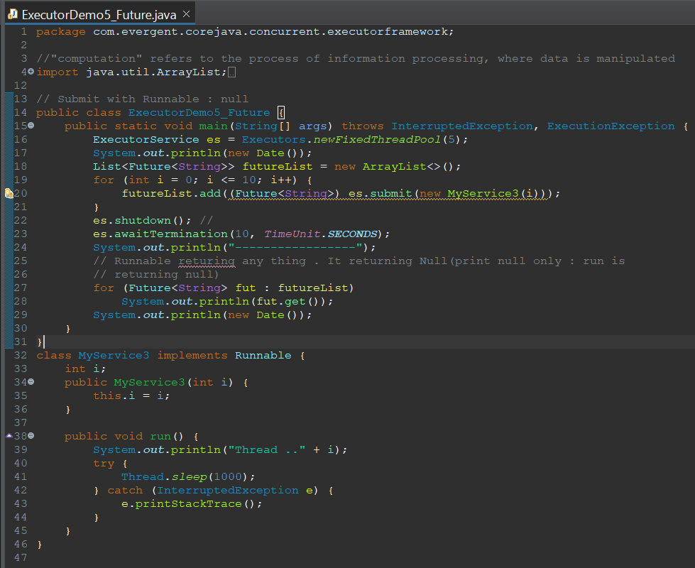

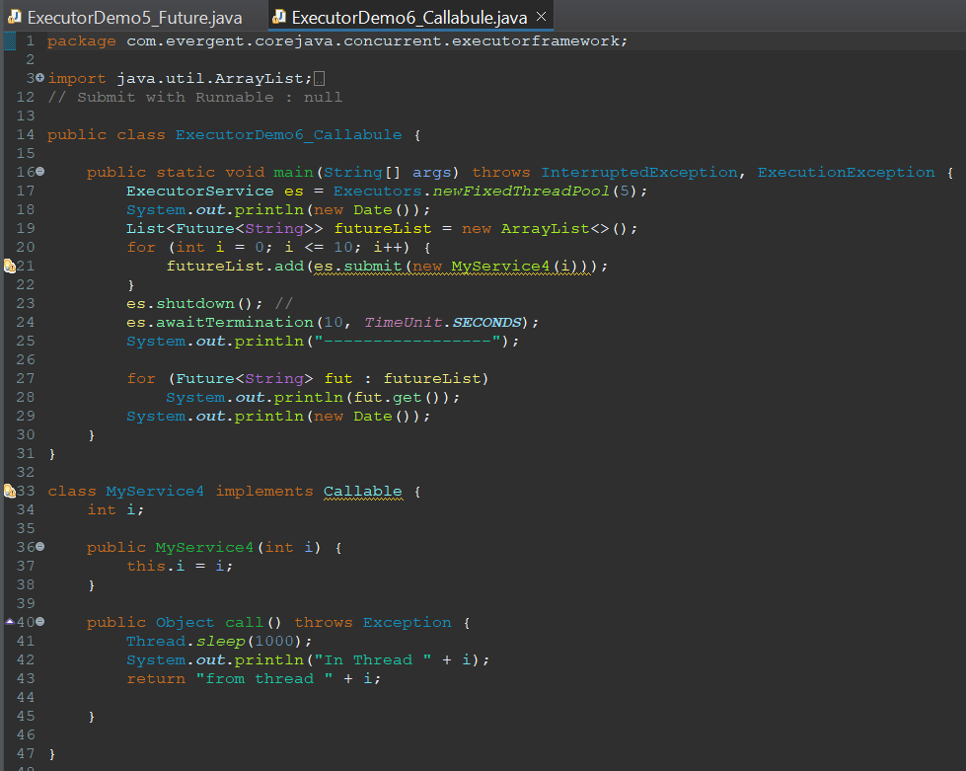

1. **JDBC**  
   JDBC - Java Database Connectivity  
   It contains some steps to insert data into database from java and perform manipulation operations.

**Steps :-**   
 1) Load Driver  
 2)Create URL  
 3) Get connection from Driver Manager class   
 4) Create Statement, Prepared Statement, Callable Statement using to write queries and send from java to data base using connection object.   
 5) Create result set to get the data from data base.  
 6) Iterate through result set to get or process data   
 7)Close connection

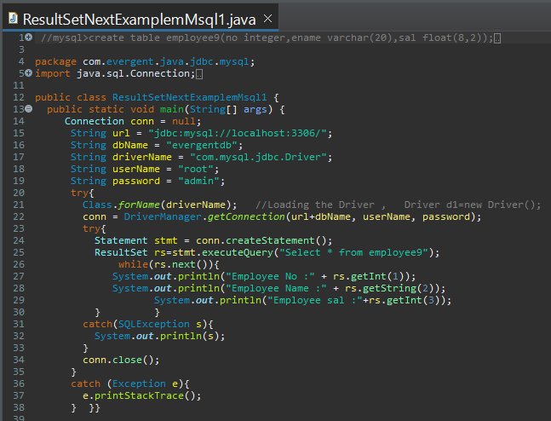

1. **Layer wise architecture**Writing whole code in one file will make confusion and lead to errors and bug fixing becomes complex. So we create different layers to segregate our code.We have DAO layer to put Data base related logic.  
   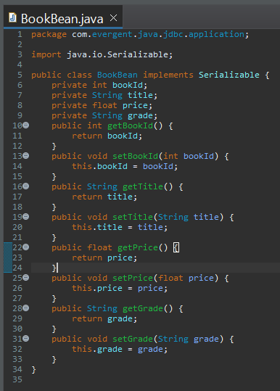  
   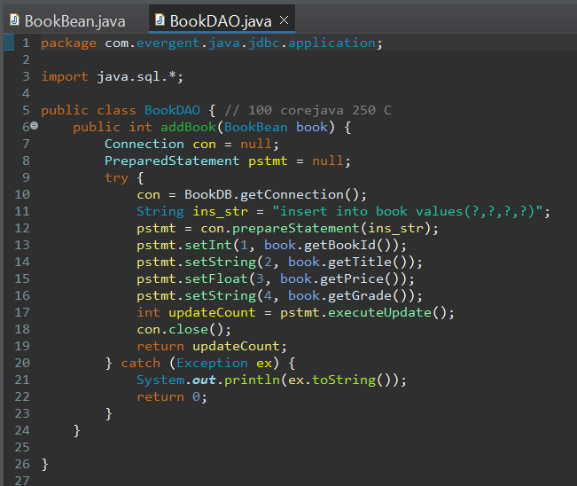  
   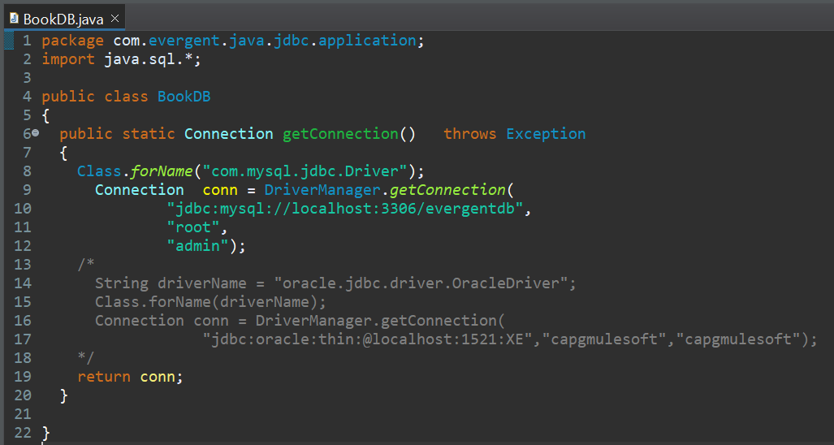  
   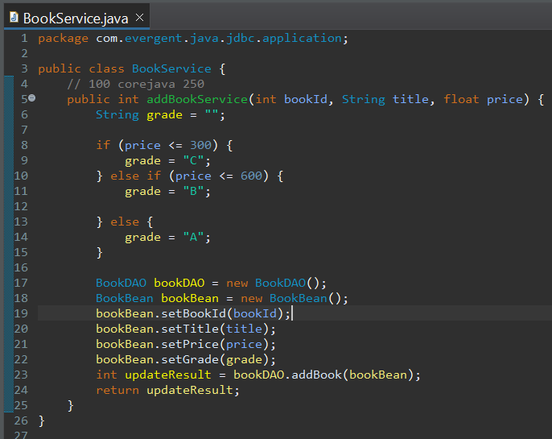

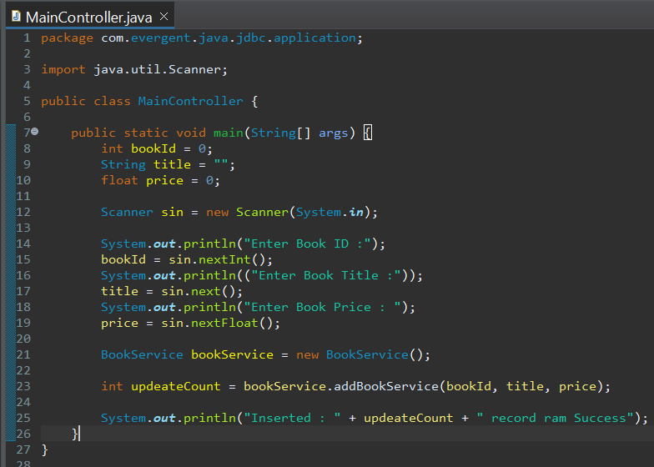

1. **Anonymous Inner class**We cannot create object of interface, but we can create object by mentioning braces{ } with semi colon; which acts as anonymous inner class and we need to override the method of interface.  
   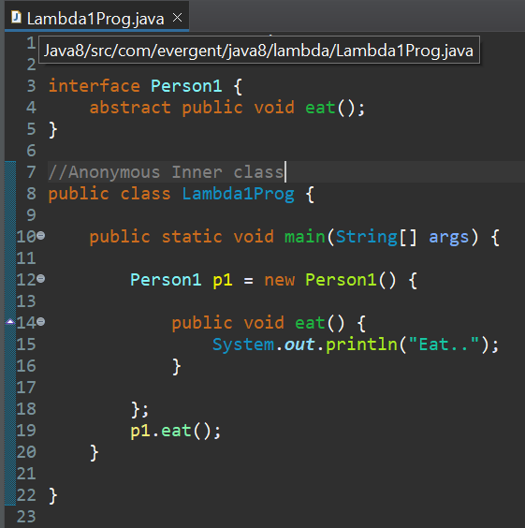
2. **Java 8 Features  
   1)Lambda**It is a function with out name, but it has body and arrow.  
   It is used to reduce the line of code and improves performance.  
   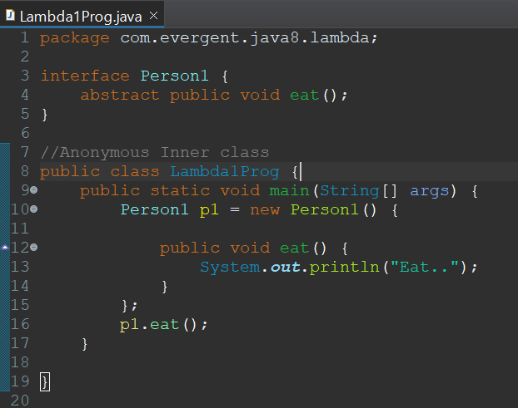

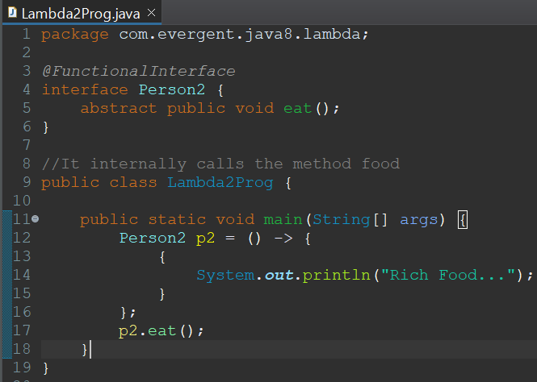

Lambda with single parameter  
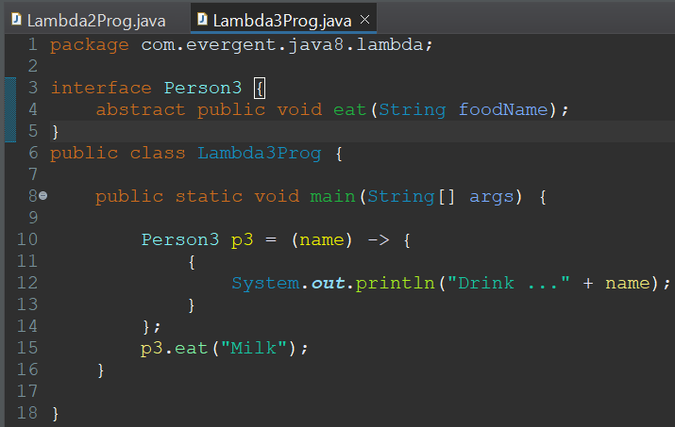

Lambda with single parameter but without paranthesis  
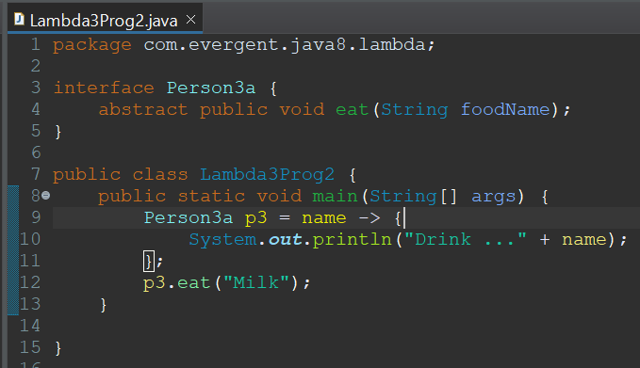

Lambda with 2 parameters  
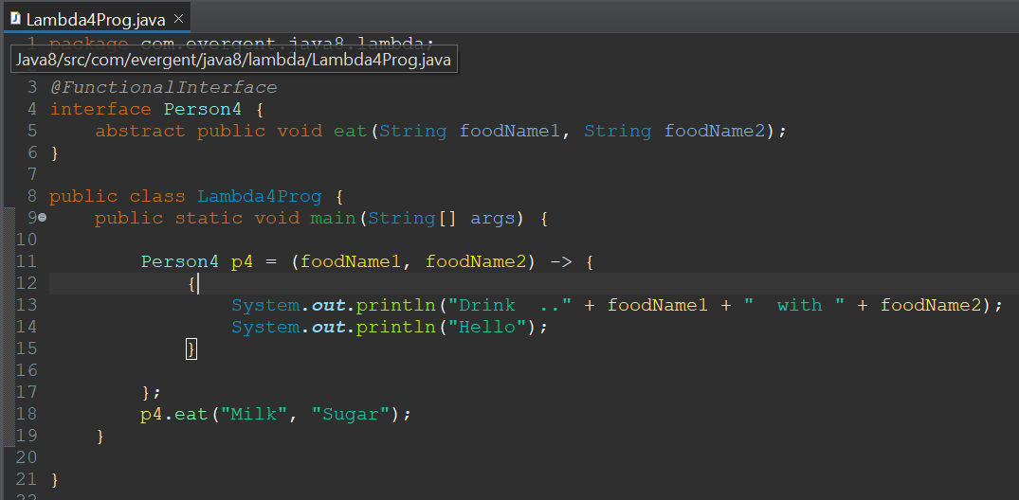

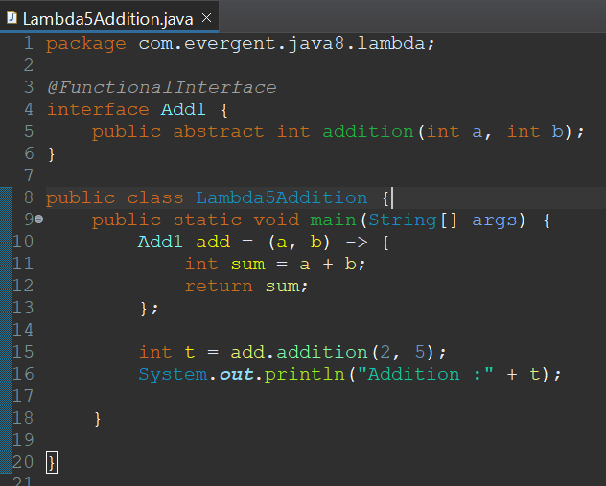  
Using lambda in for each loop   
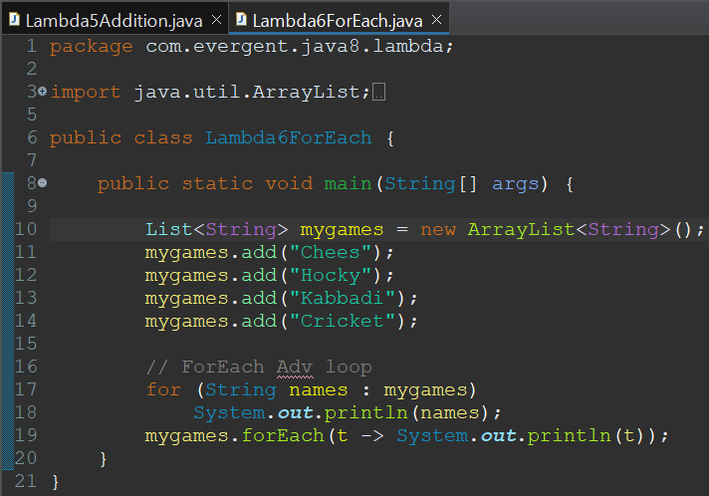

Using method reference  
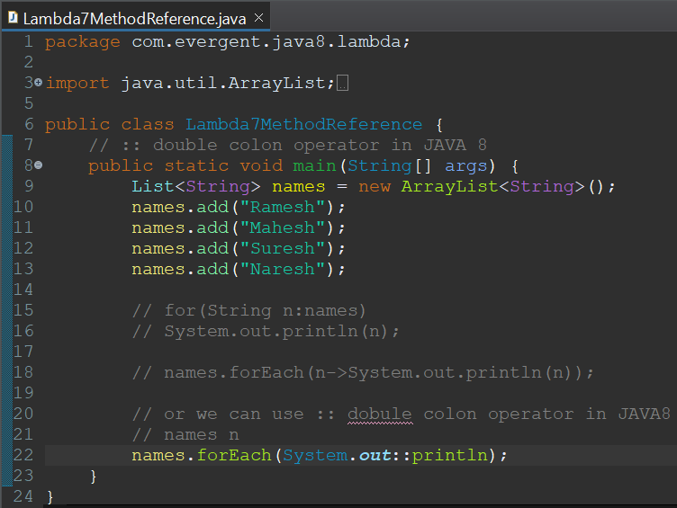  
  
Printing numbers using different approaches  
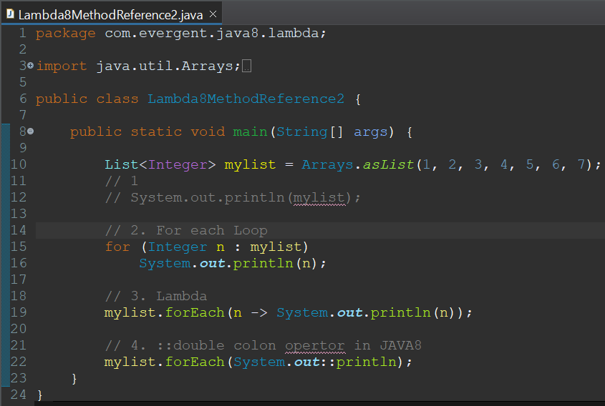

1. **Stream API**It is a java 8 feature which is used to take the collection data and perform processing on that collection data.

Stream API with method reference.  
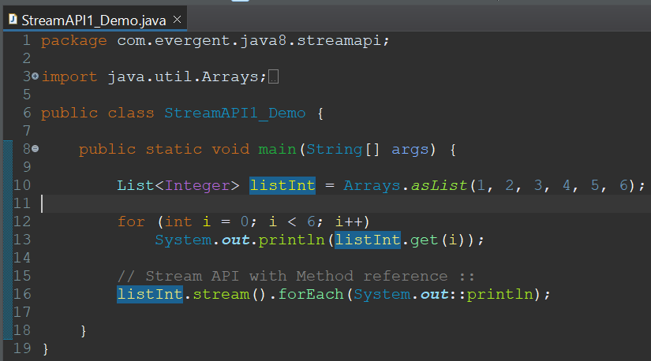

Distinct() method of stream api used to print distinct elements  
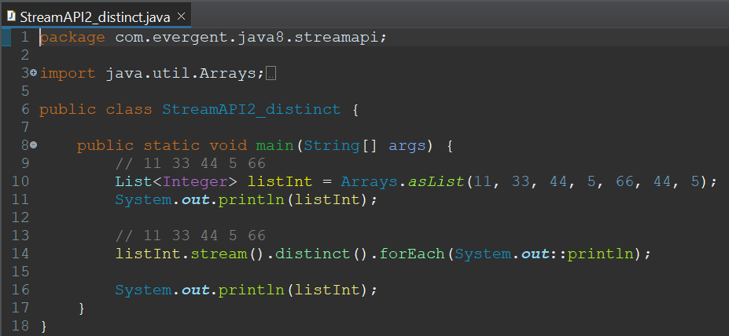

Limit() method of stream api is used to print the limited number of values.  
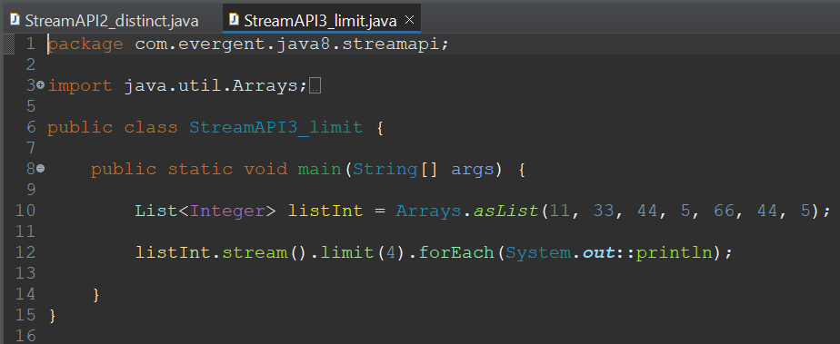

Skip() method is used to skip the number of elements and print rest of them.  
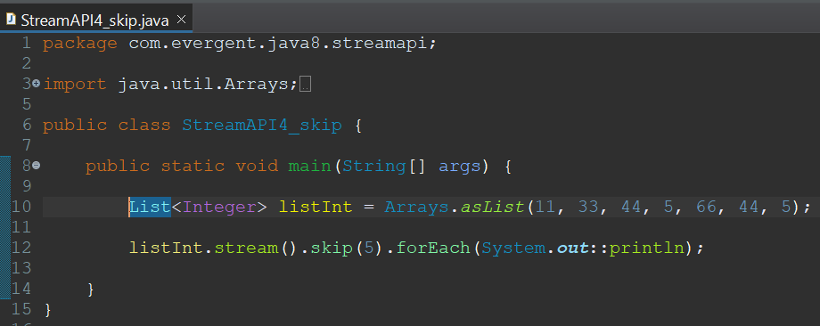

Map() method of stream api is used to perform some operation on stream data and print those values.  
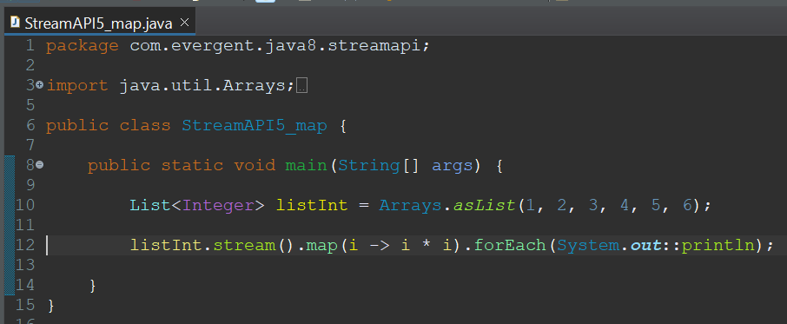

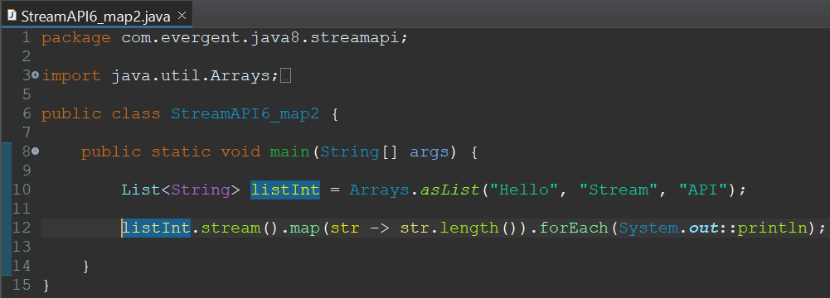

Using stream api we can also perform processsing on user defined data types.  
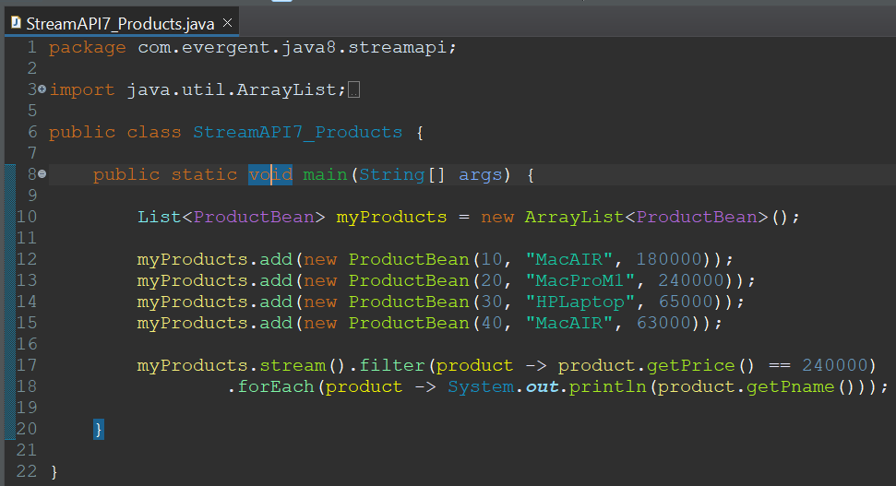

1. **Date Time API**java.time package consists of DateTime API.

LocalDate class is used to provide us date  
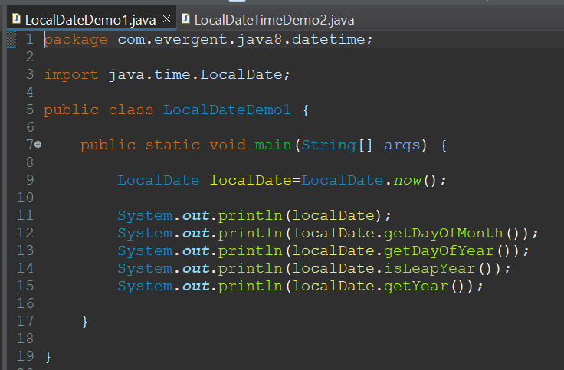  
  
LocalDateTime consists of both date and time.  
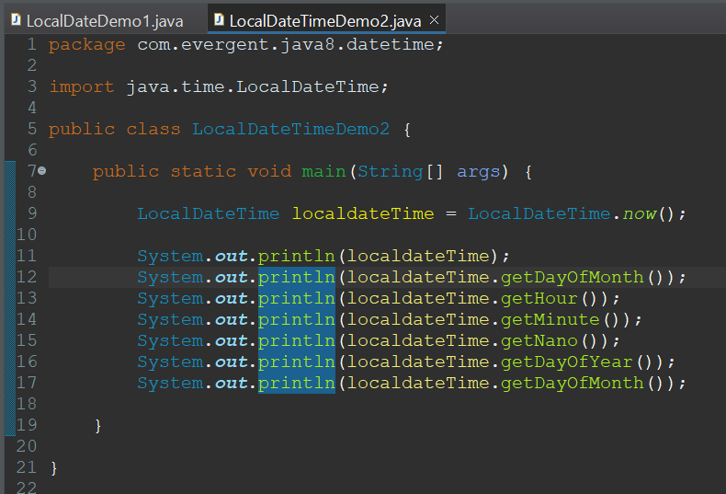

1. **Singleton Design Pattern**

Singleton class is used when we want to create a class object only once irrespective of how many times it called.

Steps :-

We should use private constructor.

We should use private object reference.

We should use public static method to get the created object.

Every object will have same hash code.

Below program is with out using single design pattern where multiple objects can be created.  
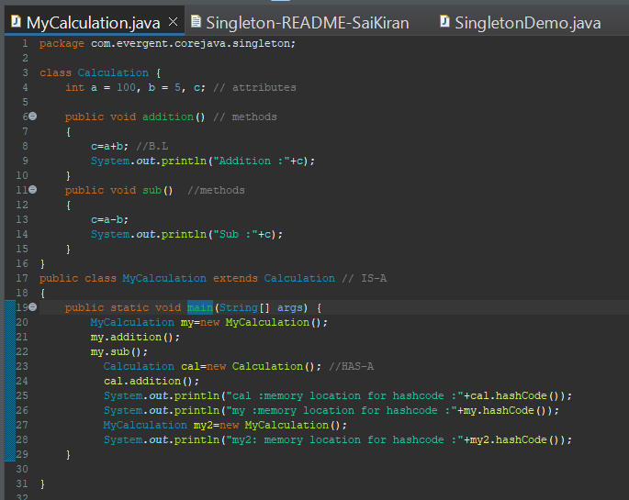

Implementation of Singleton Design Pattern where object only created once irrespective of how many times we acquired it.

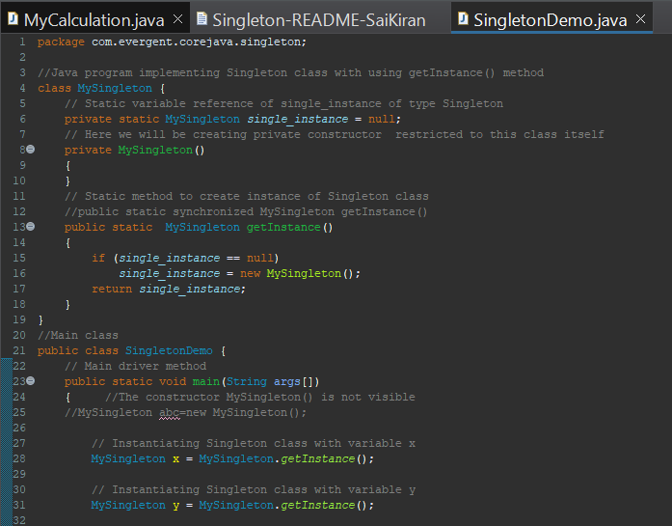  
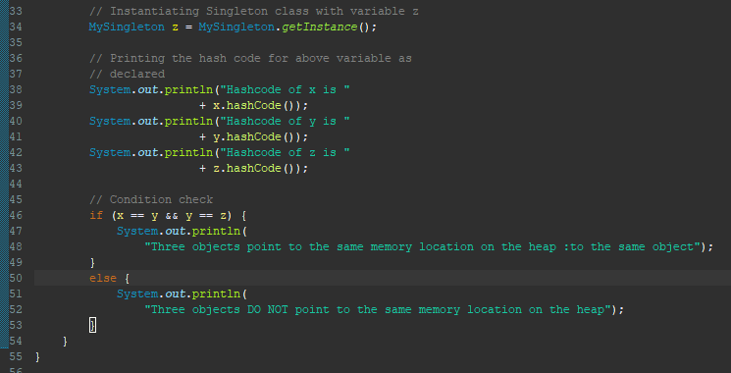

1. **MVC Design Pattern**

**->** M - Model :  It represents the business layer of application. It is an object to carry the data that can also contain the logic to update controller if data is changed.  
**->** V - View : It represents the presentation layer of application. It is used to visualize the data that the model contains.  
**->** C - Controller :  It works on both the model and view. It is used to manage the flow of application, i.e. data flow in the model object and to update the view whenever data is changed.  
**->** The MVC design pattern is a software architecture pattern that separates an application into three main components: Model, View, and Controller.  
**->** It is used in web development and used to organize our code.

Execution Steps :

1. A client (browser) sends a request to the controller on the server side, for a page.
2. The controller then calls the model. It gathers the requested data.
3. Then the controller transfers the data retrieved to the view layer.
4. Now the result is sent back to the browser (client) by the view.

Bookbean class acts as model.  
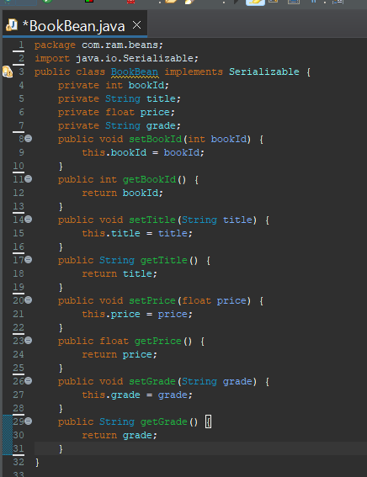

BookController acts as controller

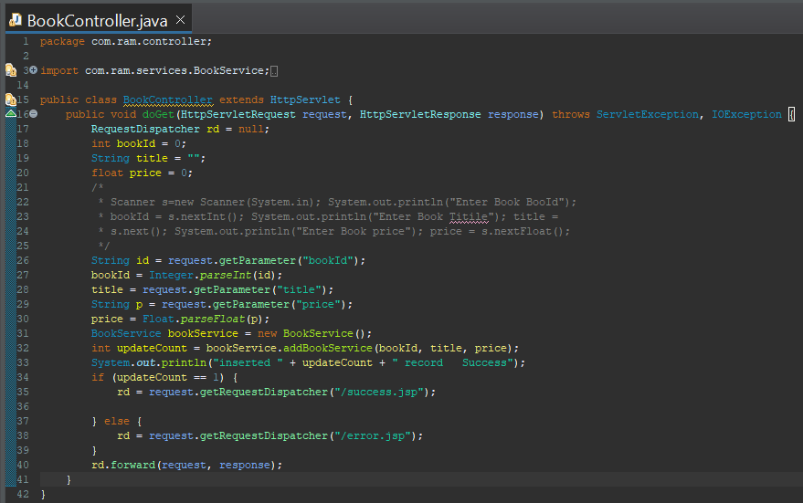

BookDAO is acts as DAO layer where data base logic is present.

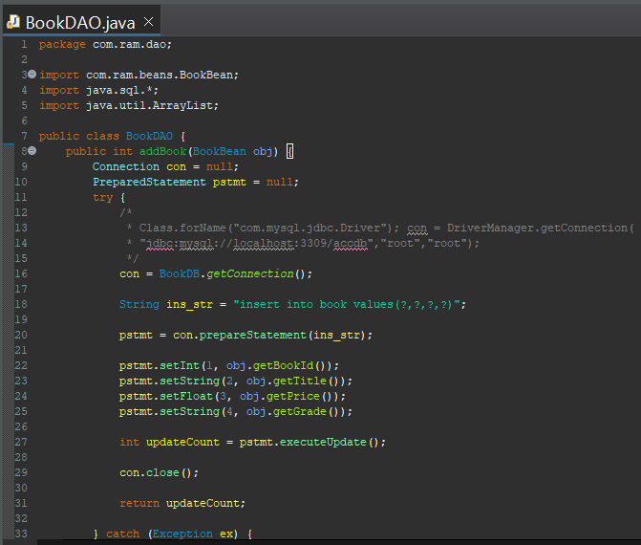

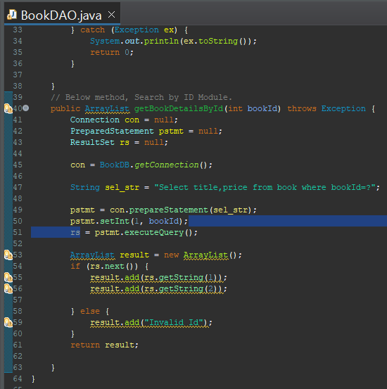

BookDB class is used to get connection of database.

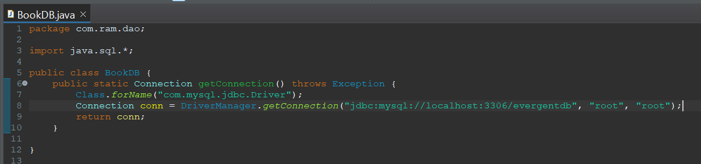

BookService class contains business logic.

